IS-305: AI Vision Based Kitting Solution for Warehousing



CDE3301 Final Report
AY 2025/26

Submitted by

Lim Kai Ler Ethan | A0307499M
Aw Shuo Jie | A0309254E
Yap Jia Wei | A0307951B
Yeo Chen Xian | A0299847Y

Supervisors
Eugene Ee | Chan Tong Leong

Acknowledgements
We would like to thank everyone who contributed to and supported us throughout the completion of this project and the preparation of this final report.
We are grateful to our group members, Lim Kai Ler Ethan, Aw Shuo Jie, Yap Jia Wei, and Yeo Chen Xian, for their teamwork, commitment, and continued contributions, even while overseas or undertaking internships.
We would also like to express our heartfelt appreciation to the Engineering Design and Innovation Centre (EDIC) for providing us with the funding and opportunity to undertake this project. We are especially grateful to our supervisors, Professor Tong Leong Chan and Eugene, for their continuous guidance, encouragement, and support throughout the project, including during the summer holidays.
In addition, we would like to thank Ms Annie and Mr Patrick for assisting us with equipment procurement and for providing valuable advice and practical guidance on soldering and mechanical design. Their support helped us overcome several technical and fabrication challenges during the development process.
We would also like to thank our module professor, Dr Aleks, for his teaching, guidance, and support during the first half of the module.
We would like to acknowledge Daryl Yap from TE Connectivity for providing the problem context and valuable industry insights. We are especially grateful for the time he dedicated to the project, including visiting with his colleagues to test and evaluate our product. His perspectives on industry practices and challenges provided us with knowledge that we would otherwise not have gained.
We extend our appreciation to our technology partner, Advantech, for sponsoring the MIC-733, touchscreen monitor, and ICAM-520, which were essential to the development and implementation of our solution.
Finally, we extend our sincere thanks to Professor Tang Kok Zuea and Mr Lim Hong Wee for serving as our examiners and providing constructive feedback that helped us further refine our project.
Each of these contributions played a vital role in shaping the success of our work, and we are truly grateful for the support we received.
Executive Summary
Context:
Kitting is the process of selecting and packing a specified set of items into a single kit. At each workstation, different components are placed in separate boxes, and the worker must pick the correct items and quantities for every kit.
The main challenge is balancing productivity and accuracy. Workers are pressured to maximise the number of completed kits while maintaining a near-zero defect rate. Errors should also be identified as early as possible, as defects discovered at later stages are more difficult and costly to trace and rectify. Therefore, the goal is to maximise the number of correctly completed kits while preventing errors at the point of packing.
Concept:
The proposed concept is a modular computer vision–assisted kitting system that combines real-time worker guidance with in-process inspection. By monitoring each packing action as it occurs, the system aims to identify errors at the point of assembly, provide immediate feedback, and guide the worker towards the correct action. This approach supports higher productivity while reducing the likelihood of defects progressing to later stages.
Solution:
To implement this concept, we developed AEGIS (the AI-Enhanced Guidance and Inspection System) a modular computer vision solution that provides real-time guidance and inspection during the kitting process. AEGIS detects packing errors as they occur, delivers immediate feedback via a UI, and guides workers through the necessary corrective actions before the kit proceeds further.
The system is designed to be non-intrusive, supporting workers without disrupting their existing workflow or requiring major changes to how they perform the kitting task. Its modular and adaptable design also allows it to be integrated into existing kitting workstations with minimal modification, enabling deployment across different workstation layouts, kit configurations, and operational requirements.
Outcome:

Acknowledgements 2
Executive Summary 3
Chapter 1: Problem Introduction 6
1.1 Problem Significance 6
1.2 Root Cause Analysis, Current Solutions and Limitations 6
1.4 Stakeholder Requirements 7
1.5 Functional Requirements 8
1.6 Value Proposition & Scope 11
1.6.1 Project Scope 11
1.6.2 Value Proposition 12
Chapter 2: Design Overview 13
2.1 Concept Overview 13
2.2 Design Selection 13
2.2.1 System Selection 13
2.2.2 Detailed Selection 14
2.2.3 Finite State Machine (Operator workflow and edge cases)? 14
Chapter 3: Prototype Development 15
3.1 Physical Frame 15
3.1.1 Fixed Near-Overhead Camera and Addressable Two-Tiered Grid 15
3.1.2 Fixed Slotting 15
3.2 Sensors 16
3.2.1 Computer Vision 16
3.2.1.1 Bin recognition 16
3.2.1.1a Rim-centric 16
3.2.1.1b Horizontal bounding-box representation 16
3.2.1.1c Operational Constraints and Parameter Performance 17
3.2.1.2 Hand-pose model 17
3.2.1.3 Spatial Bin Assignment 17
3.2.1.4 Occlusion Gating 17
3.2.2 Load Cells 18
3.2.2 Load Cells 19
3.3 User Interface 19
3.3.1 Frontend 19
3.3.2 Backend 20
Chapter 4: Testing, Evaluation and Iterations 21
4.1 System Integration 21
4.2 Sensors 21
4.2.2 Load Cells 23
Chapter 5: User Testing & Validation 31
Chapter 6: Conclusion and Future Works
Chapter 7: Reflections and Lessons Learned 37
References 38
Appendix 39

Chapter 1: Problem Introduction
1.1 Problem Significance
TE Connectivity operates both low-mix, high-volume and high-mix, low-volume production processes. Low-mix, high-volume production involves repeatedly manufacturing a limited range of products and is therefore more suitable for fixed automation. In contrast, high-mix, low-volume production involves frequent changes in product type, component combinations, and order quantities, requiring greater flexibility.
Manual kitting is used to support this high-mix, low-volume environment by allowing operators to prepare different combinations of components for each order. However, the process depends heavily on workers correctly identifying, counting, and packing parts across a wide variety of components. This creates the risk of wrong parts, missing parts, and incorrect quantities.
These errors can lead to rework, material replacement, production delays, additional logistics, and customer complaints. TE Connectivity estimates that kitting-related Cost of Poor Quality ranges from USD 10,000 to USD 20,000 per line annually. Therefore, reducing kitting errors is necessary to minimise avoidable costs and prevent defective kits from affecting downstream operations.
1.2 Root Cause Analysis, Current Solutions and Limitations
Kitting errors occur because manual packing depends heavily on human attention and judgement. Even with proper training and experience, workers may still make mistakes due to fatigue, stress, repetitive tasks, distractions, or time pressure. Although these factors can be reduced, they cannot be eliminated completely. As a result, a certain level of defect risk will always remain in manual kitting operations. A detailed breakdown of the worker’s actions and the multiple potential points of failure is provided in Appendix [X].
Current solutions address this issue in different ways. One common approach is to inspect the completed kit by weighing it and comparing the measured weight against the expected value. However, this method does not guarantee that every defect will be detected. A kit containing incorrect items may still pass the check if its total weight matches the expected weight. Furthermore, the system only indicates that the kit is incorrect without identifying the specific item or action that caused the error. This can result in additional time being spent manually inspecting the kit or restarting the entire kitting process.
Another approach is the use of a guidance system that instructs workers on which item to pick at each stage. While this reduces uncertainty and guides workers through the required sequence, it does not necessarily verify that each instruction has been followed correctly. If the worker selects the wrong item or quantity, the system may not detect the mistake or provide an alert.
Robotics and full automation may also reduce human error, but they are generally less suitable for high-mix, low-volume environments. Frequent changes in product configurations and order requirements demand a level of flexibility that can make automated systems costly and difficult to reconfigure.
Therefore, the main limitation of current solutions is their inability to detect and identify an error at the moment it occurs. Errors may only become visible after the kit has been completed, making them more difficult and time-consuming to rectify.

1.4 Stakeholder Requirements
The AEGIS system serves a diverse set of stakeholders whose requirements must be identified and balanced in the system design. These stakeholders span the operational, managerial, technical, and commercial dimensions of TE Connectivity's manufacturing enterprise, as well as the academic context of the project.
Stakeholder | Role | Primary Requirements | Key Concerns
Ground Operator | Primary end-user of the system at the kitting workstation | Minimal disruption to kitting rhythm; clear and immediate error feedback; system must not add handling steps | Cycle time impact; ease of use; false alarm frequency
Production Supervisor | Oversees cell kitting lines and operator performance | Reliable error capture; visibility of operator compliance; minimal supervision overhead | System reliability; alert accuracy; ease of monitoring
Plant Production Manager | Responsible for line throughput and cost performance | Reduction in COPQ; no degradation of throughput; low total cost of ownership | ROI; system uptime; scalability across lines
Quality Engineer | Responsible for in-process and outgoing quality assurance | High detection rate for missing and wrong components; audit trail of kitting events | False negative rate; traceability; integration with QC processes
TE Connectivity (Organisation) | Problem owner and industrial partner | Deployable across China, Poland, and Mexico plants; adaptable to varied environments; cybersecurity and data sensitivity compliance | Generalisation across sites; IP and data protection
End Customer / Client | Recipient of kitted component orders | Correct components delivered in correct quantities; elimination of replacement orders | Order accuracy; delivery reliability
Maintenance / Plant Engineer | Responsible for system upkeep and configuration for new SKUs | Simple onboarding process for new components; minimal specialist expertise required for configuration | Onboarding time; calibration ease; hardware serviceability
AdvanTech (Hardware Partner) | Supplier of edge computing and HMI hardware used in the system | Hardware must be featured and validated within the prototype | Hardware compatibility; performance validation
Table 1.1: Stakeholder requirements summary.
Several tensions exist across stakeholder requirements that inform design trade-offs throughout the project. The ground operator's requirement for minimal cycle time impact is in tension with quality engineers' desire for high detection coverage; this trade-off is addressed by designing the system to operate passively during normal kitting and to intervene only upon detection of an anomaly. The production manager's cost sensitivity is addressed by positioning the system's total hardware cost below the lower bound of the annual per-line COPQ figure of USD 10,000, thereby ensuring a favourable return on investment within the first year of deployment.

1.5 Functional Requirements
The functional requirements of AEGIS are derived from the operational problem characterised in Sections 1.1 through 1.3 and from the stakeholder requirements defined in Section 1.4. They are presented below as discrete, verifiable requirements, distinguished from non-functional considerations where appropriate.
ID | Category | Requirement | Rationale
FR-01 | Component Identification | The system shall identify which component type is present in each active kitting bin at the operator workstation. | Enables part-specific rather than aggregate verification; prerequisite for wrong-part and missing-part detection.
FR-02 | Wrong Part Detection | The system shall detect when a component placed into a kit does not correspond to the component specified in the active order. | Directly addresses the wrong-part error type identified as a primary failure mode.
FR-03 | Missing Part Detection | The system shall detect when the kit is completed with one or more required components absent or below the specified quantity. | Missing parts represent the highest-priority error type due to their direct impact on customer order fulfilment.
FR-04 | Quantity Verification | The system shall verify that the quantity of each component placed into the kit matches the quantity specified in the order. | Quantity errors (too few or too many) are not reliably detectable by gravimetric methods alone due to weight tolerance and cancellation effects.
FR-05 | Real-Time Alerting | The system shall notify the operator of a detected error at the workstation display within a timeframe sufficient to enable corrective action prior to kit completion. | Proactive in-process notification is the defining capability absent from all current solutions; post-hoc detection is already partially addressed by downstream QC.
FR-06 | Corrective Guidance | The system shall present actionable corrective guidance to the operator upon error detection, specifying the nature and location of the error. | Without specific guidance, operators cannot efficiently resolve errors; vague alerts increase cycle time and operator frustration.
FR-07 | Order Integration | The system shall accept order specifications — including component identities, bin assignments, and required quantities — as inputs to define the verification context for each kit. | Verification must be order-specific; a part correct for one order may be incorrect for another.
FR-08 | New Part Onboarding | The system shall support efficient onboarding of previously unseen component types without requiring specialist machine learning expertise from plant engineers. | TE Connectivity's 4,000-SKU catalogue and ongoing new product introductions necessitate a scalable and operationally accessible onboarding process.
FR-09 | Environmental Robustness | The system shall operate correctly under varying ambient lighting conditions and shall not require modification of bin dimensions, colours, workstation layout, or operator workflow. | It is operationally infeasible to modify assembly line configurations to accommodate a verification system; the system must adapt to the environment.
FR-10 | Supervisor Visibility | The system shall provide supervisory personnel with visibility of kitting status and error events across the workstation under their oversight. | Supervisors require situational awareness without being required to physically attend each workstation.
FR-11 | Scalability | The system architecture shall support extension to multiple concurrent workstations without fundamental redesign of the per-station hardware or software stack. | Single-workstation deployment is the prototype scope; multi-workstation deployment is the intended production scenario.
Table 1.2: Functional requirements for the AEGIS system.
In addition to the functional requirements above, a few non-functional considerations that constrain the design.
ID | Category | Requirement | Rationale
NFD-01 | Performance | The system must not measurably increase the per-kit cycle time under normal, error-free kitting conditions. | Any reduction in throughput must be justified by the corresponding savings in Cost of Poor Quality (COPQ).
NFD-02 | Cost | The total hardware cost per workstation must remain below USD 10,000. | This is based on the lower bound of the annual per-line COPQ and supports a positive return on investment within the first year of operation.
NFD-03 | Deployability | The system must be deployable and configurable by plant engineers without requiring external specialists for routine setup, configuration, or onboarding. | This reduces dependency on external support and allows the system to be scaled and maintained internally.
NFD-04 | Data Security | All system processing must be performed on-device, with no production data transmitted to external networks. | This ensures compliance with TE Connectivity’s data sensitivity and production-data security requirements.
Table 1.3: Non-Functional Demands for the AEGIS system
1.6 Value Proposition & Scope
1.6.1 Project Scope
The scope of the AEGIS project, as a proof-of-concept prototype, is precisely bound to manage complexity within the constraints of available time, budget, and resources.
The following are within scope: the design, integration, and validation of a single-workstation AEGIS unit comprising computer vision and gravimetric sensing subsystems; the development of software for real-time component identification, error detection, and operator alerting; an operator-facing HMI display and a supervisor-facing display; a hardware architecture designed to support multi-workstation data aggregation, though multi-workstation physical deployment is not validated; and laboratory-based prototype validation using simulated kitting tasks representative of TE Connectivity's operational workflow.
The following are explicitly outside scope: deployment across multiple simultaneous physical workstations in a production environment; integration with TE Connectivity's enterprise resource planning (ERP) or manufacturing execution system (MES); automation of any component of the kitting process (the system is designed to work alongside manual operations); modification of existing standard operating procedures; and the handling of components that are opaque to camera-based identification due to packaging (e.g., sealed bags with no visible identifying features, where bin-level identification must substitute for part-level identification).
The prototype is validated against the generalised kitting workflow common across TE Connectivity's China, Poland, and Mexico facilities. Differences in specific workstation layouts, bin configurations, and local operating practices are treated as environmental variables that the system is required to accommodate by design, consistent with the robustness requirements stated in FR-09. The system is not required to demonstrate cross-plant deployment in the prototype phase; rather, the architectural decisions made in the prototype are required to be demonstrably extensible to multi-plant deployment.
1.6.2 Value Proposition
AEGIS addresses a well-defined operational gap: the absence of real-time, part-specific error detection and corrective guidance at the cell kitting workstation. The system's value is grounded in three distinct contributions relative to the current state at TE Connectivity.
First, AEGIS shifts the point of error detection upstream, from post-kit gravimetric verification or downstream QC inspection to the moment of component placement. This temporal shift fundamentally changes the cost profile of kitting errors: an error intercepted before kit completion requires only a simple corrective action by the operator, whereas the same error detected downstream or post-delivery incurs rework labour, material replacement, logistics, and potential customer remediation costs. The COPQ figure of USD 10,000 to USD 20,000 per line per year represents the aggregate of these downstream costs; reducing the downstream error rate directly reduces this figure.
Second, the system employs complementary sensing modalities — computer vision for visual part identification and load cell-based gravimetric sensing for continuous quantity monitoring — to achieve a detection capability that neither modality can provide independently. Computer vision enables part-specific identification, distinguishing visually similar components that share similar masses, while gravimetric sensing provides a continuous, passive quantity signal that does not require the operator to perform additional handling or scanning steps. The integration of these two data streams addresses the diagnostic ambiguity inherent in single-modality approaches.
Third, the system is designed specifically for the high-mix, manual kitting context that commercial alternatives address poorly. Its edge-deployed architecture, order-driven verification context, and environment-agnostic operational requirements allow it to function across TE Connectivity's geographically and operationally diverse manufacturing sites without site-specific infrastructure investment.
Chapter 2: Design Overview
2.1 Concept Overview
2.2 Design Selection
This section presents a morphological matrix of each feature and our options of approach towards it. It is split into two levels, 2.2.1 which covers the systemic decisions, while 2.2.2 covers the software and hardware selections
2.2.1 System Selection
Item | A | B | C | D | Reasoning
Worker Dashboard | Monitor | Physical Buttons | Audio / Voice Control |  | Provides intuitive clear instructions and feedback
Feedback Mechanism | Audio Alerts | Haptic Feedback | Visual Feedbacks |  | Non-intrusive and does not affect neighbouring working
Processing Architecture | Edge Ai PC | Raspberry Pi | Workstation Desktop | Micro Controller | Faster Processing and Industrial Grade
Mounting | Fixed Mount | Adjustable Arm | Rail Mounting |  | To minimise variables, and ensure hands are and bin visible
Item Identification | RFID | CV | Manual Initialization |  | SKUs too large for CV and RFID. Manual Init
Quantity Identification | Weight | CV | Manual Counter | Optical Gate | Weight database already established
Worker Intention | Weight | CV | Neural Implant | Optical Gate | Most Accurate and readily available models
2.2.2 Detailed Selection
Items | A | B | C | D | Reasoning
Monitor Application | Web Application | Desktop Application | Mobile Application | Terminal Based
Edge Ai PC
Hand Detection Model
Bin Boundary Model
Weight Sensors | Straight Loadcell | load cell | newton meter | diaphragm and then quantity

2.2.3 Finite State Machine (Operator workflow and edge cases)?
Chapter 3: Prototype Development
Each section - Physical Frame, Computer Vision, UI, and Load cells were prototyped independently. Only when they fulfilled their minimum criteria alone was full integration testing done.
3.1 Physical Frame
The physical frame provides the operational infrastructure required to reduce geometric and positional variables, ensuring that both the operator’s hands and the storage bins remain consistently visible to the sensing suite. The structural layout directly establishes a stable environment that reduces the down-stream computational complexity of the computer vision subsystem.
3.1.1 Fixed Near-Overhead Camera and Addressable Two-Tiered Grid
The physical setup features a rigid frame supporting an overhead camera mounted at a static height of approximately 254 cm (100 in) above the primary reference layer [Appendix A]. The workstation area is organized into and not restricted to a modular 2-layer, 6-grid-space layout. This grid enforces a systematic layout rule where larger inventory bins that span 2 grid spaces are designated for the bottom row, while small and medium bins that span 1 grid space occupy the top row [Appendix A]. This layout directly supports integration with the user interface and structural inventory rules (FR-07). Since the camera remains fixed, the overall working space is explicitly defined and invariant. This defined environment allows the computer vision model to accurately acquire the exact coordinates of each bin, provided they are placed within this working space. Once these coordinates are acquired at system initialization, they are locked for the duration of the operational session. This infrastructure satisfies the requirement for an efficient, low-overhead environment (FR-01) and allows for simplified assignment during the integration phase, as component identification can rely on this stable, relative spatial mapping.
3.1.2 Fixed Slotting
Empirical testing during picking and packing simulations revealed that lightweight and smaller bins easily shifted when items were pulled, leading to cumulative positional drift. This physical displacement caused discrepancies between actual and perceived bin positions taken from the initialisation screenshot, resulting in wrong-bin lookup failures. To resolve this, a physical slotting system was developed to secure bins into fixed load receptors, satisfying structural containment needs (FR-02). To eliminate ambiguity during the downstream hand-tracking phase, the bins must be physically separated so that their axis-aligned image bounding boxes never overlap.
3.2 Sensors
3.2.1 Computer Vision
The computer-vision subsystem comprises hand recognition, bin recognition, and their integration. This section presents the bin-recognition design as a set of key decisions, each justified by the intermediate testing that informed it and traced to the functional requirements it serves. The supporting test logs are collected in Appendix B; the physical rig on which the tests were run is described in Section 3.1.
3.2.1.1 Bin recognition
3.2.1.1a Rim-centric
Initial prototyping demonstrated that training a deep learning model to recognize specific inventory parts was unfeasible due to the vast, evolving product catalog and hand occlusions during picking. The strategy was subsequently shifted to a bin-centric paradigm. Instead of mapping the entire bin body or its contents, the training sequence was tightly restricted to the outer rectangular rim plane viewed from a bird's-eye perspective. Iterative datasets were built using layer-by-layer configurations with varying bin sizes (S, M, L) and dynamic contents. Models trained on datasets with fewer bins successfully generalized to configurations containing up to 9 bins simultaneously, demonstrating that the system treats each bin as an independent region extraction task. By training across dynamic fill levels (0%, 20%, 40%, 60%, 80%, and 100%) alongside high-reflectivity components like metallic screws and nuts, the model learned to extract the unblocked common denominator: the physical bin rim. By decoupling the detection logic from the physical appearance of the internal items, this strategy ensures the system remains robust against changing component mixes (FR-01) and varying environmental or lighting conditions without requiring physical modifications to the bins themselves (FR-09). By decoupling the detection logic from the internal items, the system seamlessly supports configuration-driven SKU onboarding (FR-08), which is detailed further in Section 3.3.2.
3.2.1.1b Horizontal bounding-box representation
Early testing evaluated single-stage and region-based instance segmentation architectures (such as the Mask R-CNN family) to trace explicit bin contours. Instance segmentation proved unreliable for static zone definition. The extracted masks expanded dynamically to enclose any inventory items protruding past the rim, making region definitions dependent on changing contents rather than the asset itself. Furthermore, segmenters generated jagged, unstable edges and hallucinated close-proximity boundaries. Oriented Bounding Boxes (OBB) and Horizontal Bounding Boxes (HBB) were subsequently evaluated. While OBB accommodates structural rotation, the fixed orthogonal grid limits angular deviation. HBB (Horizontal Bounding Boxes) was selected because it eliminates edge contour noise, minimizes computational overhead, and maintains strict axis-aligned tracking zones. The resulting box coordinates provide a highly stable area label per bin, establishing the geometric baseline required for downstream hand-in-bin spatial overlap validation (FR-05).
3.2.1.1c Operational Constraints and Parameter Performance
Prototyping observations revealed that when items physically occluded the boundary rims, the segmentation models experienced severe distortion and boundary failures. Although front-edge occlusion was mitigated by the overhead camera angle, side and rear edge occlusions compromised box accuracy. To resolve this limitation without collecting exhaustive, item-specific occlusion training sets, a strict procedural constraint was established: bins must never be overfilled past their rim limits. This no-overflow rule maintains a clear line of sight to the tracking rims (FR-09) and aligns with industrial lean manufacturing standards to prevent cross-bin contamination. Model performance was evaluated across distinct hyperparameter training scales, establishing clear variations in bounding box stability.
3.2.1.2 Hand-pose model
The system utilizes the Google AI Edge MediaPipe Tasks Hand Landmarker for real-time, on-device tracking of 21 3D hand landmarks. Running at approximately 30 frames per second on the Jetson AGX Orin edge device, this framework avoids the heavy computational cost of dense pixel segmentation. This low-latency performance enables real-time alerting (FR-05) while leaving processing headroom to support future multi-workstation scalability without hardware redesigns (FR-11). Focusing on precise digit tracking rather than ambiguous bounding boxes provides the spatial accuracy needed to reliably pinpoint operator interactions.
3.2.1.3 Spatial Bin Assignment
To translate hand landmarks into a definitive spatial location, the system employs a finger-voting algorithm focused exclusively on the index (landmark 8) and middle (landmark 12) fingertips. By filtering out other fingers, the algorithm accommodates natural tripod-grasp picking motions without modifying the operator's workflow (FR-09). The locked bin boundary containing a fingertip receives a spatial vote. If the fingers split across adjacent bins, a deepest-penetration tiebreak evaluates the interiority distance, awarding the assignment to the finger planted deepest into a bin. This strictly geometric resolution precisely identifies which physical bin is being accessed by mirroring natural human mechanics. If tracking confidence drops, the system dynamically defaults to the tip centroid or the overall hand center to maintain a continuous positional lock.
3.2.1.4 Occlusion Gating
To maintain spatial accuracy across the two-tier workstation, an occlusion gating mechanism computationally corrects camera blind spots caused by the upper shelf lip, adapting to the environment without physical layout changes (FR-09). The system implements two fallbacks to resolve hallucinated top-row hits during lower-tier picks: a proximal anchor check (reassigning hits downward if the knuckle/wrist centroid falls mathematically below the bottom bin's top rim) and a foreground-evidence gate (flagging occlusion if a local background-subtraction mask shows a foreground pixel ratio below 20%). This logic aggressively filters false alarms, ensuring notifications provide strictly accurate corrective guidance (FR-06) in real time (FR-05).

3.2.2 Load Cells
As established in the Design Overview (Chapter 2), load cells were selected as the measurement method because no other approach could reliably identify components on a consistent basis. This decision was further supported by the availability of a TE component database containing reference weights and specifications for each item, allowing measured mass to be matched against known values for verification.
The initial design consisted of a simple cantilever platform, with the load cell secured by screws and the item rest was formed from bolts. However, the bolted arrangement proved unstable and required items to be placed directly onto the load cell, which was impractical for routine use.
The second iteration introduced a circular acrylic platform to improve stability. While this allowed a small bin to be seated securely, it remained prone to tipping when the bin's contents shifted to one side, displacing the centre of gravity beyond the platform's stable region. The resulting final design for small bins was a circular disk of [X] cm in diameter, which provided adequate stability for the expected load distribution.
Larger bins presented an additional challenge. Their greater footprint required a correspondingly wider platform, but single-point load cells maintain rated accuracy only within a specified distance from their centre; off-centre loading beyond this range introduces measurement error. A larger single-cell platform would therefore improve stability at the expense of accuracy.
To resolve this trade-off, a three-load-cell configuration was adopted. Distributing the load across three points ensured that the bin's centre of gravity always fell within the triangle formed by the cells, providing both mechanical stability and accurate readings. Three cells were chosen over four because a three-point arrangement guarantees simultaneous, full contact between all cells and the platform on any surface, whereas a four-cell layout is statically over-constrained and can leave one cell under-loaded if the surface is not perfectly flat.
Furthermore, the three-load-cell configuration allowed for scalability to fit the dimensions of any bins the factory uses by just ensuring that the 3 points of contact remained within the off center loading limit.
Finally, the system's weight constraints must account for load cell resolution. A load cell's accuracy is specified as a percentage of its rated maximum capacity, with the capacity indicated by its designation: a 1 kg load cell has a maximum capacity of 1 kg and a nominal error of ±0.5 g, while a 5 kg load cell has a maximum capacity of 5 kg and a correspondingly larger nominal error of ±2.5g. As a result, a higher-capacity cell trades absolute resolution for a greater usable range. In our own testing, however, the 5 kg load cells arranged in the three-cell configuration achieved an error of ±0.5 g, comparable to that of the 1 kg unit, as the distributed arrangement reduces the load borne by each individual cell.
Because all load cells share the same physical design and form factor, they are mechanically interchangeable, allowing the appropriate capacity to be selected according to the expected item weight without modification to the platform. The required capacity is therefore driven by two factors: the weight of the components being measured and the maximum permissible weight of the bin. By industry standards, a single bin may not exceed 25 kg, with a typical "heavy" bin falling in the 10–15 kg range, which informs the upper bound of the load cell capacity required for the larger platforms.
3.2.2 Load Cells
3.3 User Interface
The User Interface (UI) functions as an active, event-driven guidance engine connecting the ground operator and supervisory personnel to the sensing suites. To maintain system responsiveness, the UI architecture decouples high-frequency sensor data processing from front-end visual rendering through an asynchronous client-server framework.
3.3.1 Frontend
The frontend subsystem operates on a touchscreen monitor at the kitting workstation. It provides intuitive, minimally-intrusive guidance during normal packing and immediate interventions upon error detection.
To establish an intuitive baseline, the frontend renders a 2D spatial layout mirroring the physical workstation grid (FR-07). This display synthesizes computer vision coordinates and active order metadata, presenting real-time hand trajectories alongside aggregate mass telemetry so the operator can passively monitor progress without manual weighing steps (FR-04). To ensure zero cycle-time friction, the interface remains entirely passive during correct picking sequences. Upon an error trigger, it dynamically transitions to an active alert state within sub-second latency thresholds (FR-05). Instead of ambiguous alarms, the frontend presents targeted, location-specific guidance: the erroneous bin is highlighted in high-contrast colors, and clear text prompts specify the exact required corrective action (FR-06). The interface requires physical error remediation before allowing the order sequence to advance, preventing defective kits from proceeding downstream.
Additionally, the frontend incorporates a remote supervisory view accessible over the local network. This aggregates live operational statuses, historical error logs, and shift throughput metrics across active lines, granting supervisors situational awareness without requiring physical attendance at the workstations (FR-10).
3.3.2 Backend
The backend subsystem constitutes the core event processing and state evaluation engine. Operating as an asynchronous background service, it ingests 30 FPS hand-landmark tracking and continuous load-cell mass data into an in-memory state repository. This asynchronous Inter-Process Communication (IPC) architecture prevents UI rendering from blocking the primary vision pipeline, delivering sub-50 ms latency for real-time alerting (FR-05) while preserving computational headroom for future multi-workstation scalability (FR-11).
The core decision logic is governed by a deterministic Finite State Machine (FSM) that evaluates incoming sensor streams against pre-loaded order rules. To achieve accurate wrong-part detection, the FSM compares the spatially assigned bin ID (derived from the computer vision subsystem) against the active order manifest, immediately triggering an anomaly state if an unprescribed bin is accessed (FR-01, FR-02). Simultaneously, it evaluates signed mass deltas against unit component weights to flag quantity discrepancies (FR-04). Upon order completion, the FSM verifies that all required SKU quantities have been satisfied before authorizing kit sign-off (FR-03). Because the architecture relies on bin-centric vision and derives pick counts directly from passive weight changes, new component types are onboarded seamlessly by simply updating the configuration database with the new SKU identity and unit mass, preserving full verification coverage without requiring AI model retraining (FR-

Chapter 4: Testing, Evaluation and Iterations
While Chapter 3 detailed the rapid prototyping of each subcomponent in isolation to ensure they individually met all functional requirements, this chapter focuses on the system-level integration and evaluation. We first integrated all components to construct the complete prototype, and then conducted rigorous developer testing for each subsystem, followed by end-to-end integration testing. This testing phase was crucial to ensure the system was fully robust and ready for the formal user testing and validation phase presented in Chapter 5.

4.1 System Integration
The integration of the system directly follows the system architecture diagram established in Chapter 2. A central pipeline orchestrator was developed to coordinate the real-time data flow between the computer vision, load cell, and HMI subsystems, bringing the isolated components together into a unified architecture.
The physical deployment of the AEGIS prototype brings together the structural CAD designs from Chapter 3 into a fully realised workstation. As shown in Figure 4.1, the complete setup features the overhead camera mount, the integrated load-cell receptor platform beneath the bins, and the operator-facing HMI dashboard. This integrated environment allows for seamless testing of the combined computer vision and weight-sensing pipeline.
Once initialised, the real-time processing loop executes continuously. Each frame follows the sequence shown in Figure 4.2: camera capture, hand tracking, bin assignment, weight delta evaluation, FSM state update, and HMI refresh.
The CV and load cell threads write to a shared PipelineState object, while the FastAPI web server reads from it independently. This decoupling ensures that the sensing loop runs at full frame rate regardless of HMI refresh timing.
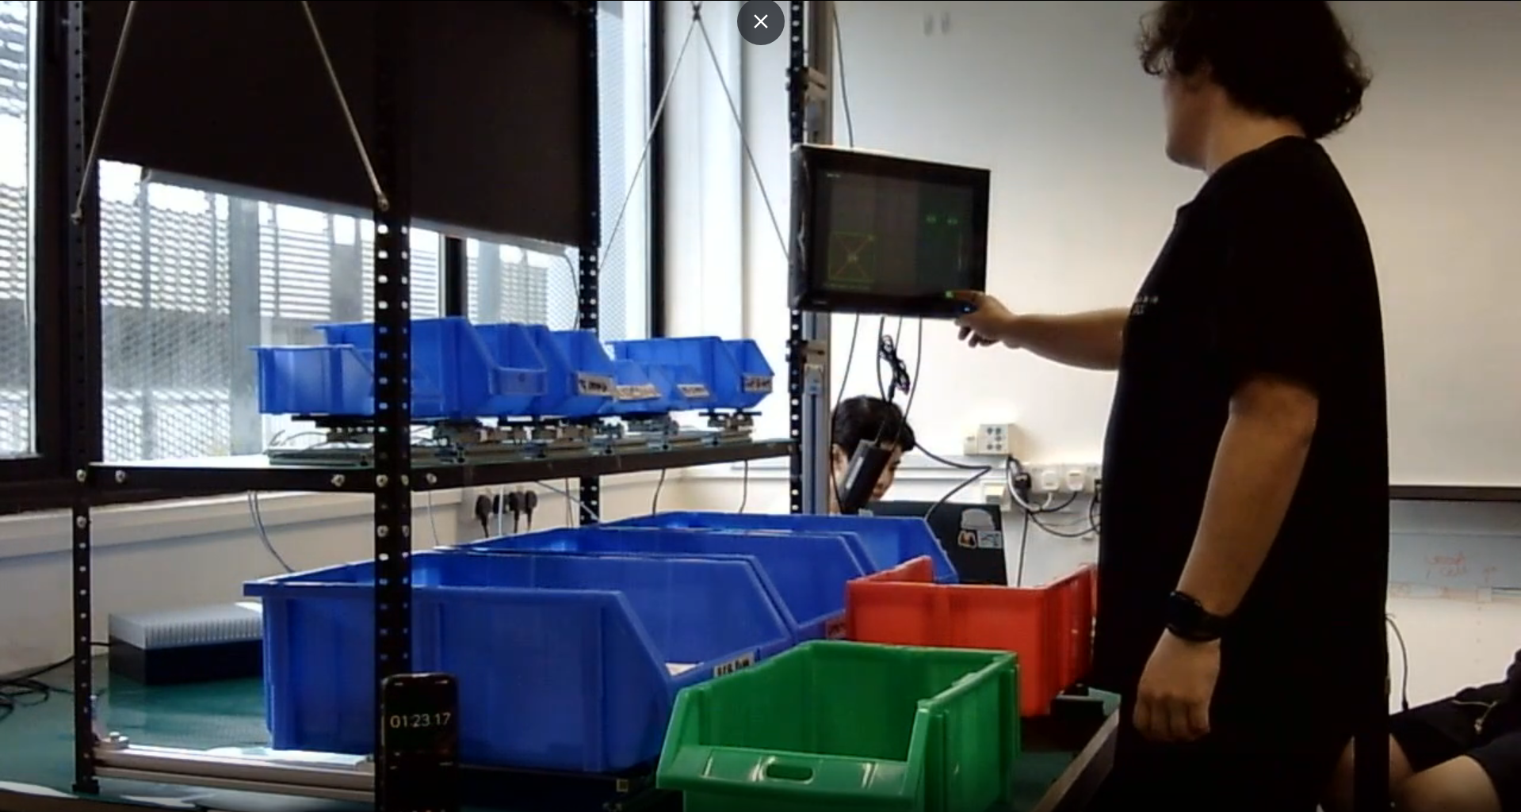
Figure 4.1: Fully integrated AEGIS workstation setup, transitioning from the Chapter 3 CAD model to the physical prototype.
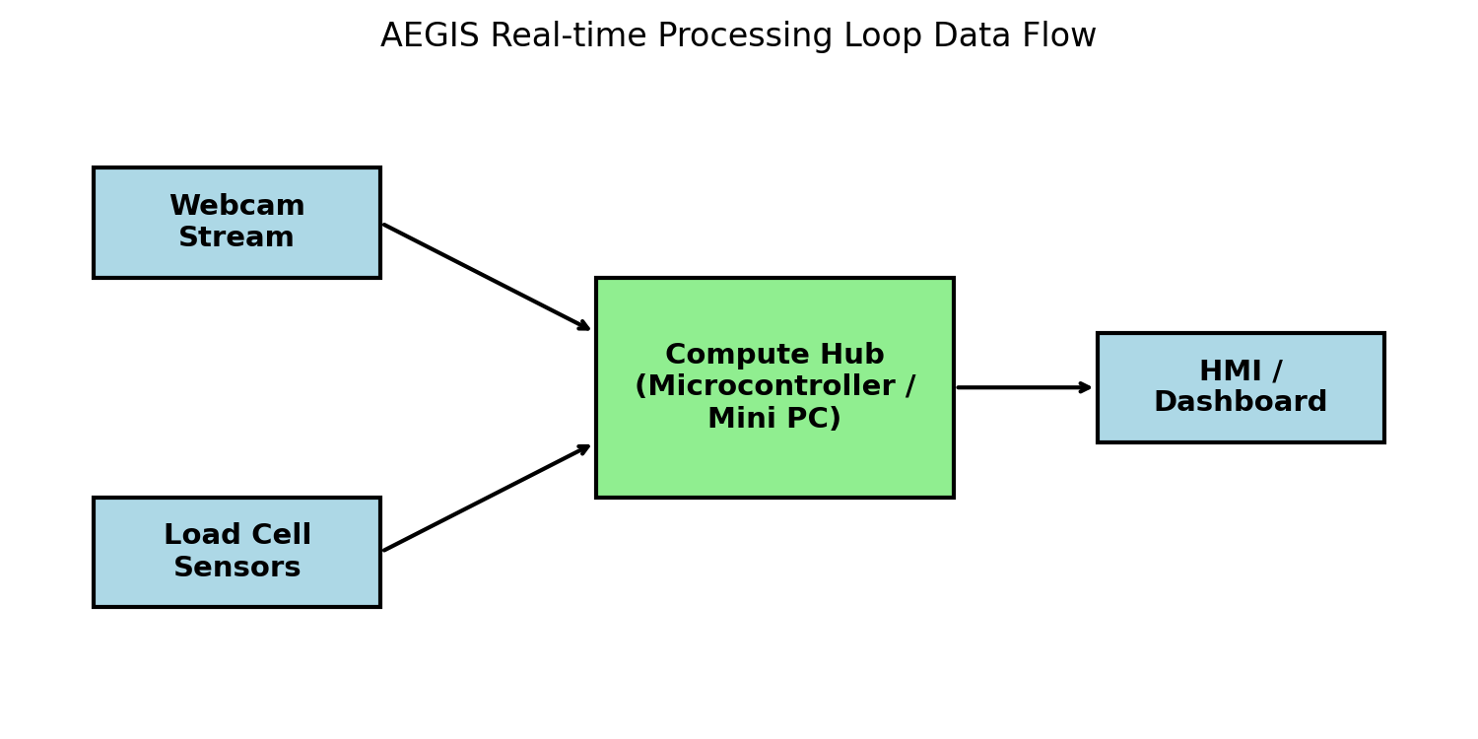
Figure 4.2: Real-time processing loop data flow diagram.

4.2 Sensors

4.2.1 Computer Vision

4.2.1.1 Testing Framework
The CV detector was evaluated using a layer-by-layer permutation protocol designed to test invariance to bin position, colour, and fill level. Testing proceeded across three setup groups, each isolating one variable. The test conditions are summarised in Table 4.1.
Group | Variable Tested | Conditions
A | Bin colour and layout | A1: 9 blue bins (baseline); A2: mixed red/green/blue; A3: blue + mixed set
B | Bin contents and fill level | 7 item categories at 3 fill levels (empty, partial, full). Items tested: matte connectors, reflective brackets, shiny screws, PVC pipes, copper rods, dark connectors, mixed items
Lighting | Ambient illuminance | 8 levels from approximately 0 lux to 506 lux; 9 bins measured per level (72 readings total)

Table 4.1: CV testing conditions.
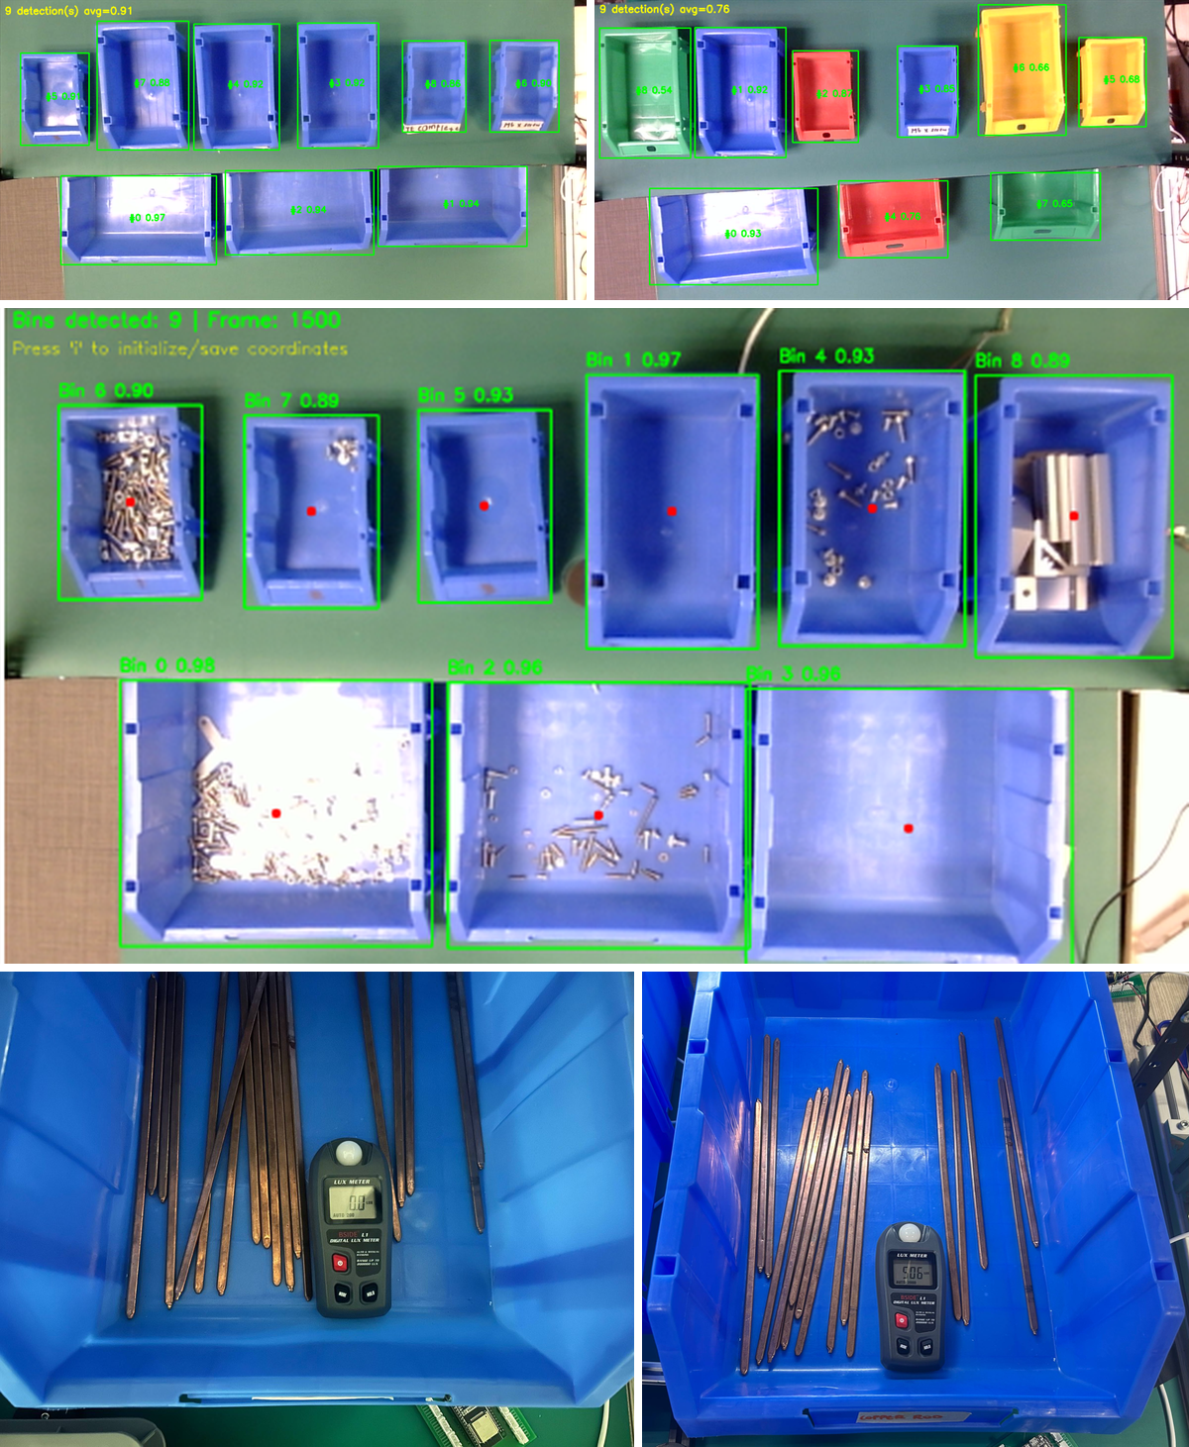
Figure 4.3: CV test setups. (a) Group A baseline with all blue bins. (b) Group A2 with mixed colours. (c) Group B with varied items at different fill levels. (d) Lighting sweep with lux meter.

4.2.1.2 Evaluation Results
Group A Results
Under condition A1, the model achieved 100% detection across 20 sample frames. When non-blue bins were introduced under conditions A2 and A3, detection accuracy decreased to 80% and 85% respectively, as shown in Figure 4.4. Analysis of the failure cases revealed hallucinated bounding boxes when non-blue rims were present. This finding informed the decision to standardise on blue bins for the deployment configuration.
[INSERT FIGURE HERE]
Figure 4.4: Group A detection results. (a) A1: 100% detection. (b) A2: hallucinated bounding box example. (c) Accuracy comparison across the three conditions.
Group B Results
With standardised blue bins, detection held at 100% across all seven item categories at every fill level, including copper rods protruding above the bin rim, as shown in Figure 4.5. This confirms that the model is rim-centric and content-invariant.
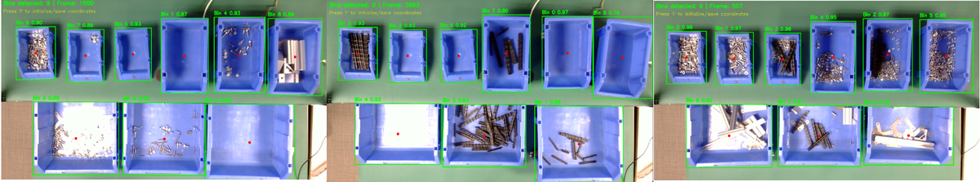
Figure 4.5: Group B sample detections across item categories and fill levels.
Model Validation Metrics
The fullness-varied model (Setup V3) achieved the validation metrics shown in Table 4.2. Training curves are presented in Figure 4.6.
Metric | Value
Precision | 0.999
Recall | 1.000
mAP50 | 0.995
mAP50-95 | 0.935
Epochs | 55 (early stopping at epoch 54)

Table 4.2: YOLOv8-OBB validation metrics (Setup V3).
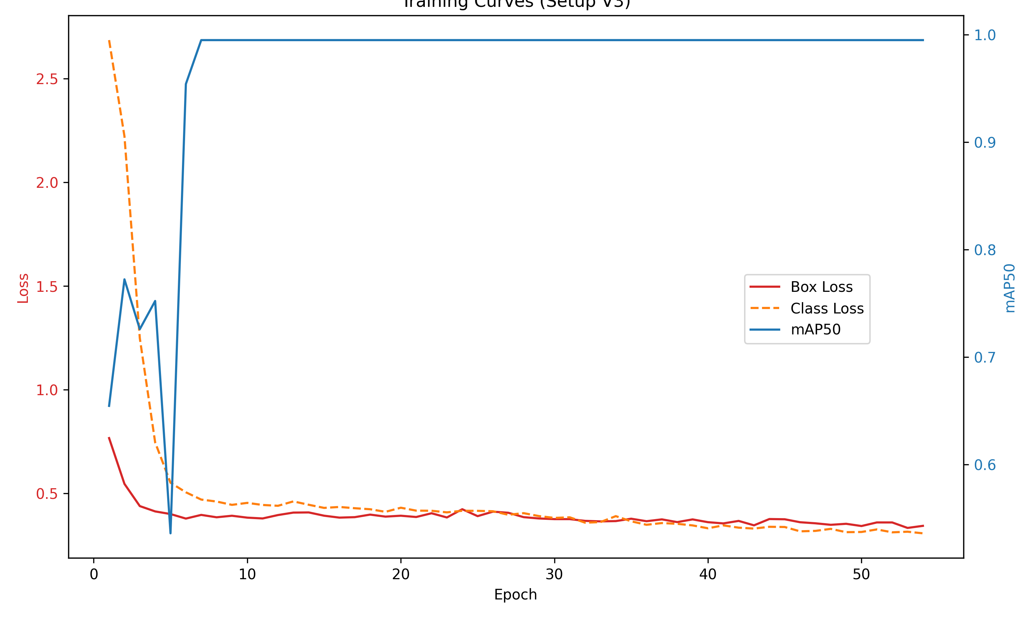
Figure 4.6: Training curves for Setup V3, showing loss convergence and mAP over epochs.
Lighting Characterisation
Detection held at 100% across all 72 readings, including near-darkness at approximately 0 lux. As shown in Figure 4.7, confidence correlated weakly with illuminance (Pearson r = 0.27 linear, r = 0.40 log-lux) and the trend was non-monotonic. The rim-centric detector is not lighting-limited over the station's operating range, satisfying FR-09.
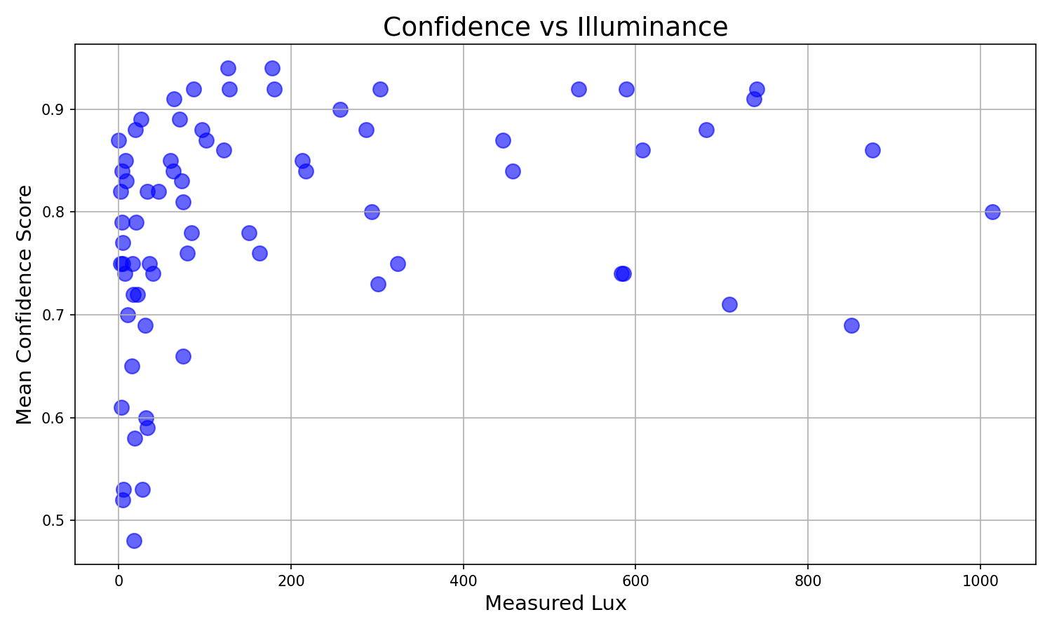
Figure 4.7: Lighting characterisation results. (a) Lux readings across 9 bins at 8 levels. (b) Confidence versus illuminance scatter plot. (c) Sample detections at approximately 0 lux and 506 lux.
4.2.2 Load Cells
4.2.2.1 Testing Framework
The load-cell subsystem underwent a structured measurement-system qualification, conducted independently of the computer-vision and UI subsystems and prior to full-system integration testing. The qualification was structured across three tiers: Capability (whether the platform resolves the masses at stake), Stability (whether the reading holds over time), and Integration (behaviour under off-centre, freehand loading).
Platforms under test.
For the 5 kg and 10 kg platforms, three individual load cells share one rigid base and one bin, with bridge outputs summed in hardware ahead of the HX711 — each platform reports one combined weight, not three independent readings.
Load cell hardware. All cells are YZC-133 strain-gauge load cells (rated 1–10 kg depending on configuration), each platform paired with one HX711 24-bit ADC. The performance figures below are published by the component supplier; they are not corroborated by an independent manufacturer datasheet, and are used in this report only as an engineering reference point for interpreting measured results:
Reference equipment. Loads were verified against a 1000 g-capacity, 0.1 g-readability reference scale, using a graded reference-mass kit of individually-weighed sand bags labelled with actual (not nominal) mass. Loads above 1000 g were built by stacking multiple weighed bags, so the ±0.1 g uncertainty per bag accumulates with stack size. The reference scale's 0.1 g readability also sets a practical floor of roughly 0.5 g on how finely the 1 kg platform's low end could be verified.
Test scope. The full battery below was run on one representative unit per configuration, reflecting a qualify-then-replicate sequence: each platform design was validated on a single built unit first; only once that unit demonstrated sufficient performance were the remaining two units of each configuration built and brought into service.
Test protocol summary.
Test A7 does not appear in the underlying qualification data and is intentionally absent from this report.
Interpreting results against a target. The YZC-133 figures above are per-cell and supplier-published, not independently verified, so they are used below only as an approximate reference — scaled to each platform's rated full-scale (F.S.) capacity. This matters most for the 5 kg and 10 kg platforms: the spec characterises one cell in isolation, while these platforms sum three cells into a single reading, so combined error is not guaranteed to track a single cell's rated tolerance. Legal-for-trade frameworks (e.g., OIML R76) were considered as an alternative benchmark but set aside, consistent with the project's position that AEGIS targets industrial-adequate accuracy, not certified legal-for-trade metrology.
4.2.2.2 Evaluation Results
Capability
A1 — Minimum detectable mass. The smallest mass reliably separated from the zero-noise band was ~0.5 g (1 kg platform), ~2.3 g (5 kg), and ~4.3 g (10 kg). Using the informal heuristic that reliable single-pick counting needs unit mass ≥5–10× the zero-band σ (σ = 0.028 / 0.223 / 0.433 g respectively), the 1 kg platform's floor sits inside that range (0.14–0.28 g); the 5 kg and 10 kg platforms' measured floors sit at or just above the upper bound of their equivalent ranges (1.1–2.2 g and 2.2–4.3 g).
A2 — Repeatability. Against the scaled per-cell targets (0.5 g / 2.5 g / 5.0 g):
The 5 kg, 75% row uses a corrected value: Trial 4 was logged as 2751.151 g, inconsistent with the other four trials (~3750 g) and the row's own printed mean/SD; the confirmed correct value of 3751.151 g is used above.
The 1 kg platform stays within target at every load level tested. The 5 kg and 10 kg platforms sit close to or within target at 50%, then exceed it at 75–100%.
A3 — Hysteresis. Max |up − down| deviation: 0.087 g (1 kg, at 500 g), 5.44 g (5 kg, at 2500 g), 16.99 g (10 kg, at 7500 g) — against scaled targets of 0.5 g, 2.5 g, and 5.0 g respectively.
Stability
A4 — Warm-up drift. All three configs shown at matched timestamps (5 kg/10 kg were logged at coarser 10-minute intervals in the source data; the 1 kg series is shown at the same four points for a fair comparison):
Corrected: the source data listed +0.90 g drift at this point, inconsistent with the reading itself; the reading (5009.76 g) was confirmed correct, giving a drift of −0.10 g.
None of the three platforms show a clear plateau within the 30-minute window: the 1 kg and 10 kg platforms are still trending at t=30; the 5 kg platform's apparent easing between t=20 and t=30 is based on only two points past its peak.
A5 — Creep. At 100% load: 1 kg = +0.055% (+0.55 g) over 15 min; 5 kg = +0.035% (+1.76 g); 10 kg = −0.058% (−5.80 g). These figures are not directly comparable to the supplier's creep spec, which is rated over a 3-minute window rather than the 15 minutes tested here.
Integration
A6 — Off-centre / placement sensitivity.
For the 10 kg platform, the largest deviation occurred at the seam between cells A and B rather than directly over a single cell; the test mass used was larger than the individual load platform it was placed on, so at that position it likely bridged more than one cell rather than resting cleanly on one.
A8 — Settling time. All three platforms settled in under 1 second at every step size tested (1 kg: ~0.4 s; 5 kg: 0.4–0.6 s; 10 kg: 0.4–0.6 s, increasing modestly with step size).
Observed pattern
Across A2, A3, and A6, a consistent pattern is present in the data: the single-cell 1 kg platform stays within its scaled per-cell tolerance across every metric tested; the two summed 3-cell platforms (5 kg, 10 kg) track close to or within the naive per-cell target at low-to-mid load, then diverge further from it as load approaches full scale. Since A2's freehand lift-and-replace protocol does not fix exactly where on the platform a bin lands, the placement sensitivity measured directly in A6 is a plausible contributor to the repeatability and hysteresis figures seen at higher loads on the two summed platforms.

4.3 Backend Verification (Unit Testing)

4.3.1 Testing Framework
The verification logic is encapsulated as a pure, hardware-independent placement-tracker component (Section 3.3.3), enabling isolated testing with deterministic inputs. The pytest suite feeds per-bin and kit-box weight sequences into the tracker and asserts the resulting FSM state at each step. The test cases cover bin activation and debounce confirmation windows; placement counting, target-reached completion, and bin banking; all four fault types (Overpack, Out-of-Sequence, Wrong-Bin, Returned-to-Wrong-Bin) and their auto-clear conditions; and various edge cases, including post-tare settle windows, sensor drift compensation, transient dips, and light-item crediting floors derived from the qualification results in Section 4.2.2.

4.3.2 Evaluation Results
All 134 test cases across 16 modules pass. Coverage results are presented in Table 4.3 and Figure 4.8.
Module | Statements | Coverage
placement.py (FSM core) | 196 | 98%
bin_assignment.py | 260 | 83%
occlusion_hold.py | 35 | 100%
grid_allocator.py | 107 | 93%
grid_calibrator.py | 79 | 96%
grid_session.py | 74 | 95%
inventory.py | 45 | 78%
cycle.py | 39 | 100%
Overall project | 2,569 | 50%

Table 4.3: Unit test coverage summary (134/134 passing).
The 50% overall figure reflects deliberate targeting of pure-logic modules. Hardware-bound modules such as the pipeline orchestrator, dashboard server, and camera overlay require live peripherals and are not included. The core FSM module achieves 98% statement coverage, confirming that the critical state machine pathways are exercised exhaustively.
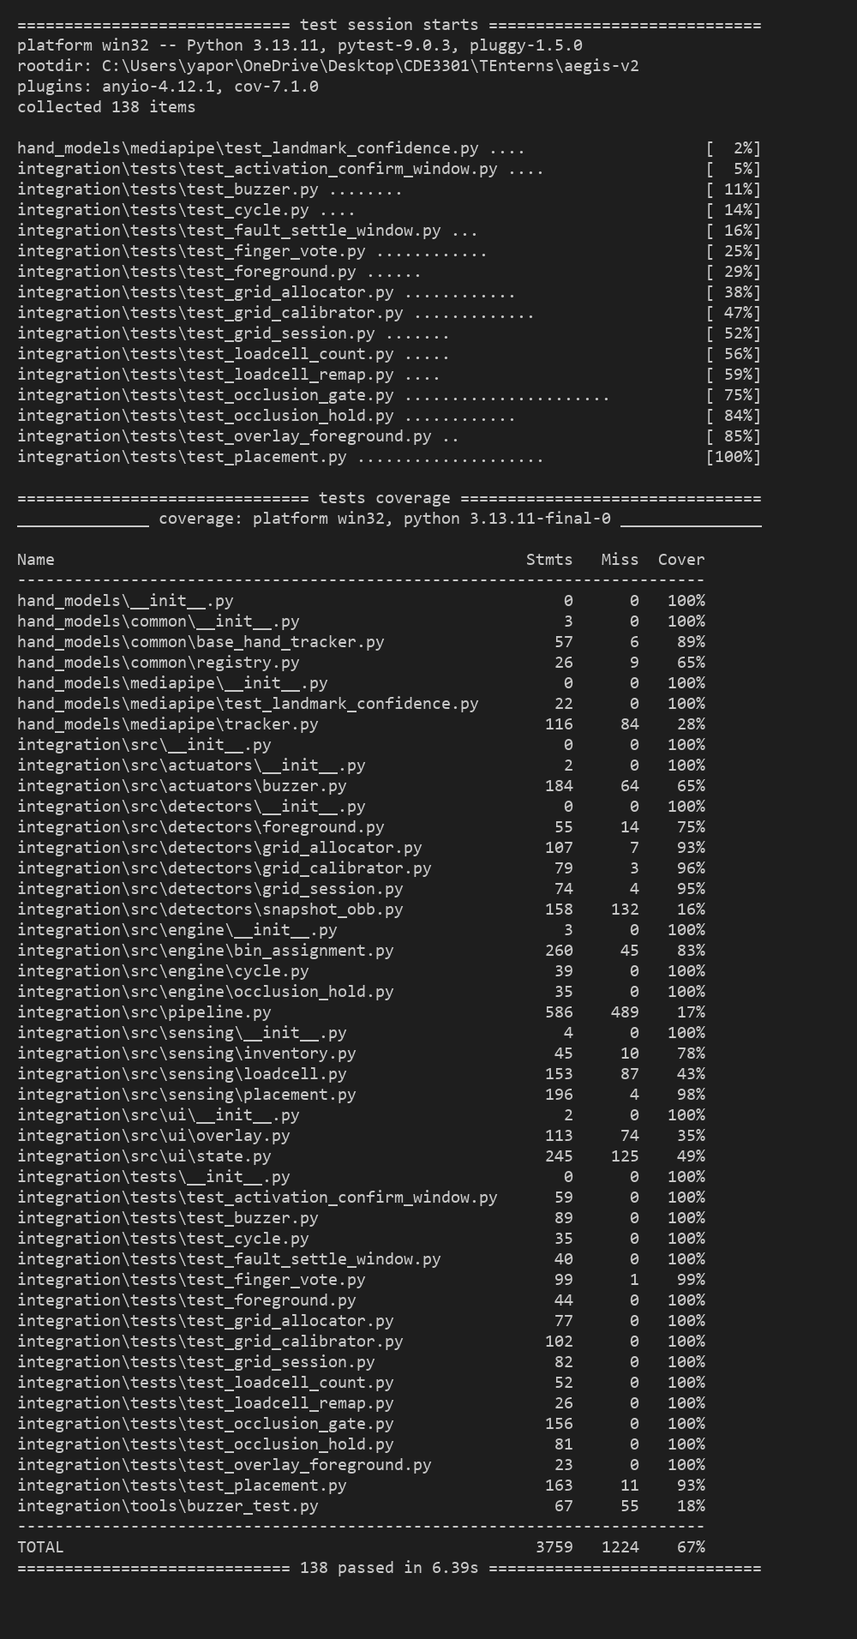
Figure 4.8: (a) Pytest terminal output showing 134/134 tests passing. (b) Coverage report summary for the core verification modules.

4.4 Developer-Phase Iterations
Two significant iterations arose from the functional testing phase. Both follow a structured gap-to-solution-to-validation pattern.

4.4.1 Hardware Iteration: Load Cell Platform Redesign
Gap: Bench testing revealed that a single cantilever load cell could not support larger bins without tipping, while expanding the platform on a single-point cell introduced extreme off-centre measurement errors [Table 4.5].
Solution: The platform was redesigned as a three-point summed load cell triangle for medium and large bin configurations. This configuration stabilises the centre of gravity within the support triangle while the HX711 summation circuit maintains a single-channel interface to the microcontroller, preserving full software compatibility.
[INSERT FIGURE HERE]
Figure 4.9: Load cell platform evolution. (a) Initial single-cell cantilever platform exhibiting tipping instability. (b) Final three-point triangle configuration with stable bin seating.

4.4.2 Software Iteration: Occlusion Gate
Gap: During integration testing, a critical computer vision error was identified when operators reached into the bottom row of bins. The shelf lip of the two-tier rack physically occludes the operator's fingertips, causing MediaPipe to extrapolate the index fingertip upward into the geofence of the top-tier bins. This produced false "Out-of-Sequence" and "Wrong-Bin" alarms, as illustrated in Figure 4.10a-b.
Solution: An Occlusion Gate was implemented within the bin assignment engine. The gate verifies the position of the hand's proximal anchors (wrist landmark and MCP knuckle centroid), which remain visible below the shelf lip even when the distal joints are occluded. When these anchors are detected at or below the bottom-bin boundary, the gate overrides any fingertip-derived top-bin assignment and forces the correct bottom-bin assignment [Figure 4.10c].
A stateful Occlusion Hold module was additionally developed to address complete hand disappearance behind the shelf lip. The hold module maintains the last-known bottom-bin assignment for a configurable timeout (default: 500 ms), releasing only when the hand reappears.
Both modules are covered by the unit test suite: 22 test cases for the gate and 12 for the hold, all passing. The combined effect eliminated the false-alarm issue in subsequent integration testing.
[INSERT FIGURE HERE]
Figure 4.10: Occlusion Gate operation. (a) Side-view schematic showing the shelf lip occluding fingertips during a bottom-bin reach. (b) Without the gate: false top-bin assignment. (c) With the gate: proximal anchor detection overrides to the correct bottom bin.

Chapter 5: User Testing & Validation
This chapter presents system-level validation of the integrated prototype, comprising a developer user study, the HMI iteration driven by operator feedback, a final stakeholder validation with TE Connectivity, and the formal requirements traceability matrix.

5.1 Usability Study

5.1.1 Testing Framework
The integrated system was evaluated through a structured usability study with six operators conducted between 8 and 13 July 2026. The study employed a within-subjects, counterbalanced design in which each operator completed a paper-based Control block and an AEGIS System block with three bills of materials (BOMs) per block. Block order was counterbalanced across participants to control for learning effects. The participant schedule is shown in Table 5.1.
Each session comprised three phases: (1) a structured alert walkthrough across all four fault types, (2) a rating interview across nine dimensions scored on a 1 to 5 Likert scale, and (3) an open-ended interview capturing free-form feedback. The nine dimensions were selected to separate task communication (what and how many to pack) from exception communication (warnings, errors, and corrective instructions).
Operator | Date | Group | BOM Order
Benny | 8 Jul | * | 1, 2, 3
Chloe | 8 Jul | B | 2, 3, 1
Ming Zhan | 8 Jul | B | 2, 1, 3
Song Yi | 9 Jul | A | 2, 1, 3
Royce | 10 Jul | A | 3, 2, 1
Jack | 13 Jul | B | 1, 3, 2

Table 5.1: Participant schedule. *Benny's session used an earlier protocol (pilot).
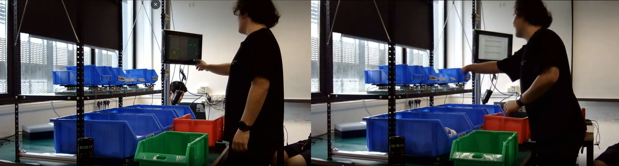
Figure 5.1: Usability study setup. (a) Operator using AEGIS during a kitting task. (b) Paper-based control condition.

5.1.2 Evaluation Results
Operator ratings are summarised in Table 5.2. The distribution of individual ratings is shown in Figure 5.2.
ID | Dimension | Mean | Range | n
R1 | Screen wording clarity | 3.3 | 2 to 5 | 6
R2 | Layout and placement of information | 4.2 | 3 to 5 | 6
R3 | Ease of understanding what to pack | 4.9 | 4.5 to 5 | 6
R4 | Ease of understanding how many to pack | 5.0 | 5 to 5 | 6
R5 | Running count usefulness | 3.8 | 1 to 5 | 6
R6 | Warning and error alert clarity | 3.3 | 2 to 5 | 6
R7 | Corrective instruction completeness | 3.0 | 1 to 4 | 5*
R8 | Trust that system would catch mistakes | 4.0 | 3 to 5 | 6
R9 | Overall ease of kitting with system | 4.3 | 2 to 5 | 6

Table 5.2: Operator ratings (1 = poor, 5 = excellent). *R7: n = 5 (one operator triggered no errors).
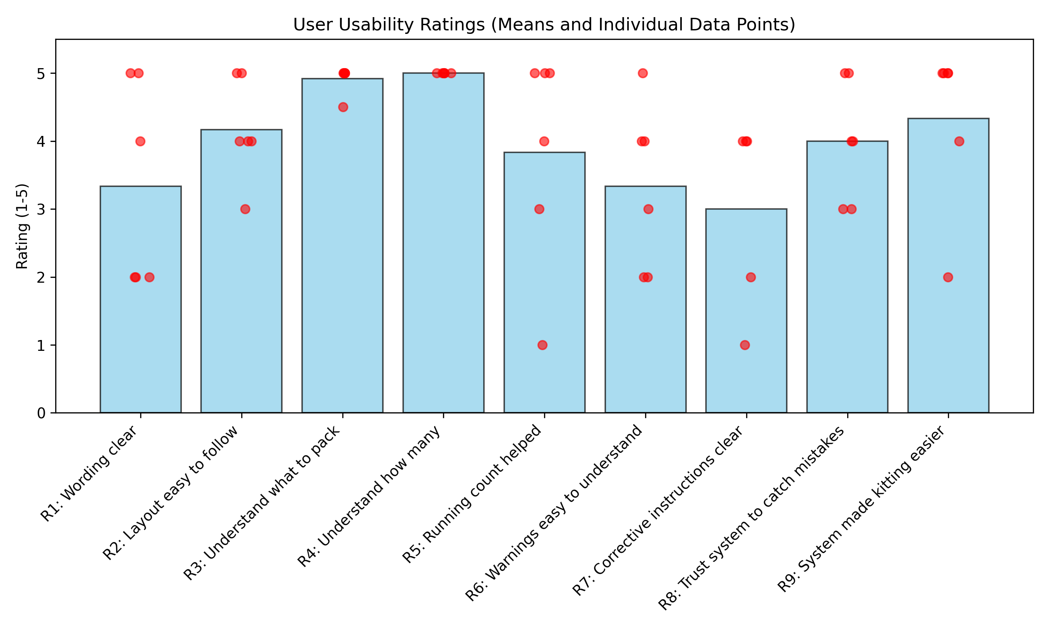
Figure 5.2: Rating distribution across the nine dimensions, showing means and individual data points.
Task guidance dimensions rated at or near ceiling: understanding what to pack (R3: 4.9) and how many to pack (R4: 5.0). The position-based bin grid was consistently cited in open-ended feedback as the primary reason. Overall, operators preferred AEGIS over the paper baseline (R9: 4.3).
The weakest dimensions concerned exception communication. Analysis of the open-ended feedback identified six specific usability gaps, as summarised in Table 5.3.
Gap | Issue | Frequency | Representative Quote
G1 | Alert font too small to read at working distance | 4 of 6 | "fonts small" (Royce); "wording small" (Ming Zhan)
G2 | Warning and error types indistinguishable at a glance | 3 of 6 | Inconsistent colour scheme (white-on-red versus red-on-black)
G3 | Corrective instructions did not specify bin or quantity | 3 of 5 (R7: 3.0) | Wrong-bin-return message lacked actionable detail
G4 | Load cell unresponsive on light items | 3 of 6 | "sensor doesn't detect piece sometimes" (Benny)
G5 | On-screen confirmation tap unreliable | 2 of 6 | "Bin Emptied" button did not register on first tap
G6 | No progress indicator for remaining sets | 2 of 6 | Operators requested visibility of order completion status

Table 5.3: Usability gaps identified from operator feedback.

5.2 User-Facing HMI Iteration
To address the usability gaps identified in Table 5.3, a targeted HMI iteration was implemented. Table 5.4 maps each gap to the specific change applied, and Figure 5.3 shows the interface before and after the iteration.
Gap | Change Implemented
G1 | Alert font sizes increased by approximately 50%, ensuring legibility at arm's length.
G2 | Dual-banner layout consolidated into a single full-width banner with a consistent red and white colour scheme.
G3 | Wrong-bin alert updated to compute and display the exact correction, specifying the destination bin and unit count.
G3 | Completed-bin picks reclassified as "Wrong Bin" rather than "Out-of-Sequence" for greater operator clarity.
G4 | Mitigated operationally by assigning light items to the 1 kg platform (noise floor s = 0.028 g). Software debounce tuned.
G5 | Manual "Bin Emptied" tap replaced with automatic load-cell-based detection on the kit box.
G6 | Remaining-sets progress indicator added to the HMI header.
General | Bin labels changed from 0-indexed to 1-indexed. Colour-coded hand-in-bin halo added (teal for valid, red for invalid).

Table 5.4: HMI iteration changes mapped to usability gaps.
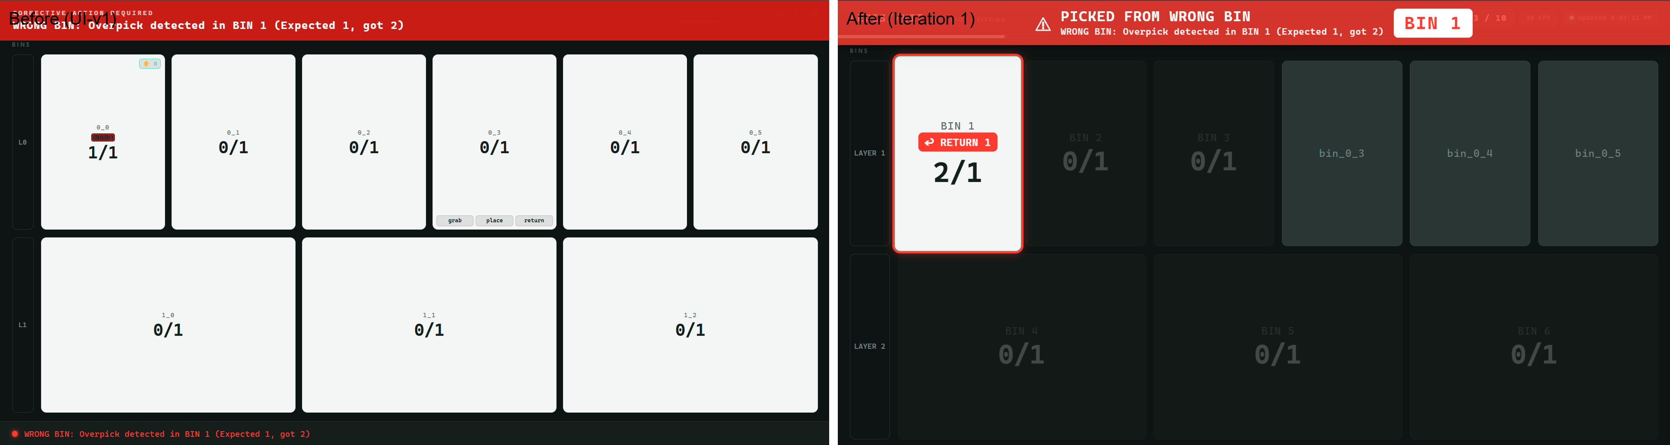
Figure 5.3: HMI before and after the iteration (side-by-side screenshots showing the old UI vs. the new UI).

5.3 Final Testing: TE Connectivity Stakeholder Validation

5.3.1 Testing Framework
Following the HMI iteration, a final validation session was conducted with representatives from TE Connectivity, the project's industrial problem stakeholder. The purpose of this session was to evaluate the integrated AEGIS prototype under conditions representative of the intended deployment environment and to gather feedback from the stakeholders who would be responsible for the system's adoption and deployment.
During the session, the stakeholder directly interacted with the system by simulating standard kitting operations. This allowed for an authentic assessment of the system's responsiveness, error detection capabilities, and the effectiveness of the UI guidance in a realistic scenario.
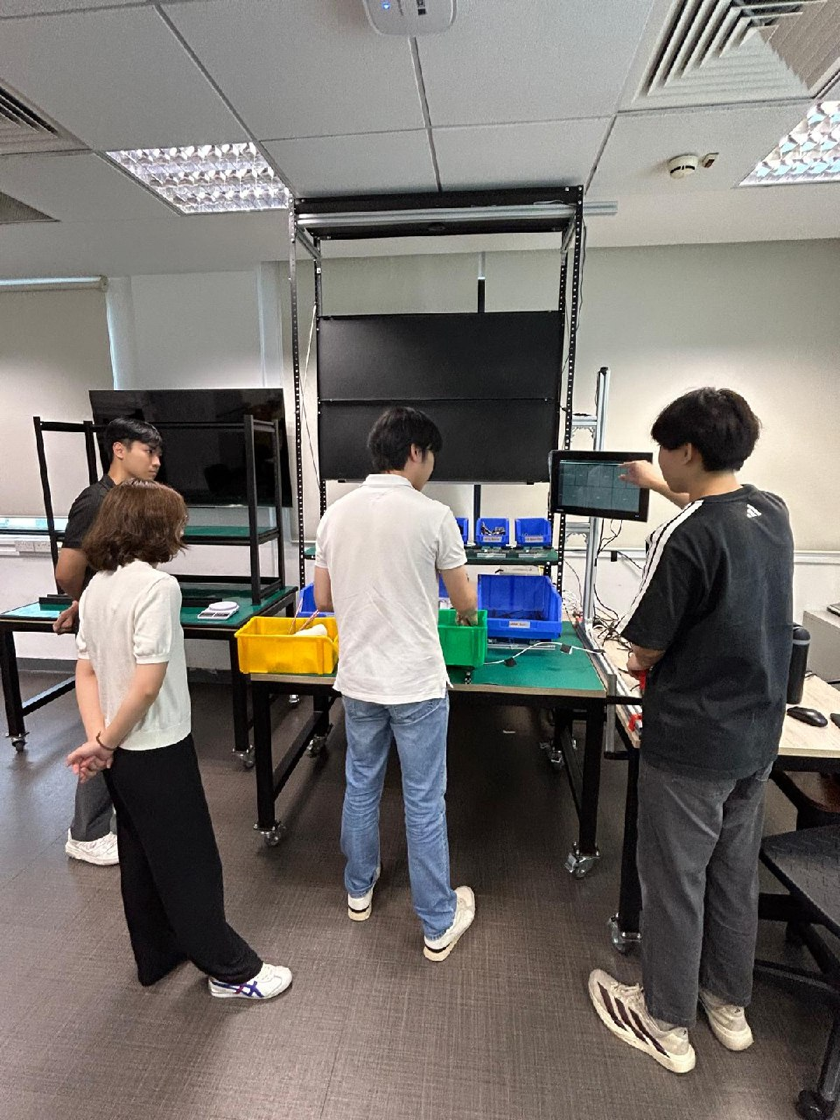
Figure 5.4: TE Connectivity stakeholder testing the AEGIS prototype during the final validation session.

5.3.2 Evaluation Results
The stakeholder expressed a strong positive impression of the integrated prototype, highlighting the robust hardware build, software logic, and the user interface. Specifically, the system's poka-yoke design was praised for its ability to catch errors on the spot, drastically reducing the troubleshooting and labor time compared to their current end-of-line weighing measures.
Several features exceeded stakeholder expectations. The tiered bin system, combined with the computer vision model's ability to function reliably with only 20% to 30% bin visibility, was noted as a crucial design success. The lighting tests and the UI indicators, which provide clear guidance for new operators, were also highly commended.
In terms of limitations, the primary concern raised was the handling of ultra-light items (under 1 gram), as debris or stray components falling into the bins could trigger false errors. However, it was agreed that this is fundamentally a process engineering challenge. An industry-standard mitigation—branching out tedious, light-item kitting into a separate process line—was discussed and deemed a viable solution. Overall, the stakeholder rated the system's deployment readiness at 80%, noting that the remaining gap primarily involves making the system easily configurable for end-users without requiring coding knowledge.

5.3.3 Stakeholder Feedback Summary
Category | Stakeholder Feedback | Recommended Action / Mitigation
System Readiness | Hardware, UI, and logic are approximately 80% deployment-ready. | Focus remaining development on improving configuration ease for end-users.
Error Prevention | Real-time poka-yoke design drastically reduces downstream troubleshooting time. | Retain and refine the real-time alert architecture.
Limitations | Ultra-light items (<1g) may trigger false errors from stray debris. | Implement process engineering mitigations, such as separating light-item kitting.
Future Scope | System overlaps significantly with other manual operations like parts assembly. | Explore adapting the architecture for assembly tracking tasks.

Table 5.6: Summary of stakeholder feedback and recommended actions.

5.4 Requirements Validation
The integrated prototype was validated against each functional requirement defined in Section 1.5. Results are summarised in Table 5.5. Requirements marked "Met" have been verified through the testing evidence documented in Chapters 4 and 5. Requirements marked "Partially Met" identify boundary conditions with documented mitigation strategies.
ID | Requirement | Status | Verification Evidence
FR-01 | Component Identification | Met | YOLOv8-OBB localises bin boundaries [Section 4.2.1]; inventory engine maps weight changes to SKU specifications via bin position.
FR-02 | Wrong Part Detection | Met | FSM triggers wrong-bin alert on access to inactive or completed bin [Section 4.3].
FR-03 | Missing Part Detection | Met | FSM blocks KIT_COMPLETE if any required SKU remains below target count [Section 4.3].
FR-04 | Quantity Verification | Partial | Met for items above 5 g. Light items (below 3.5 g) on 5/10 kg platforms occasionally missed [Section 4.2.2]. Mitigated by 1 kg platform assignment.
FR-05 | Real-Time Alerting | Met | End-to-end latency below 80 ms. Alerts appear on the HMI before the operator completes the reach.
FR-06 | Corrective Guidance | Met | Post-iteration alerts display specific bin, error type, and corrective action [Section 5.2].
FR-07 | Order Integration | Partial | System parses YAML order configurations to set targets, but loading is not fully automated. The operator must select or key in the order configuration manually.
FR-08 | New Part Onboarding | Met | Dynamic OBB calibration eliminates manual coordinate mapping. New SKUs require only a weight entry.
FR-09 | Environmental Robustness | Met | 100% CV detection from 0 to 506 lux [Section 4.2.1]. ESD mats suppress glare. No workstation modification.
FR-10 | Supervisor Visibility | Met | FastAPI serves live state over the local network; remote browser access for supervisors.
FR-11 | Scalability | Met | Pipeline utilises approximately one of twelve CPU cores. Thread-safe architecture supports multi-station extension.

Table 5.5: Requirements validation matrix.

Chapter 6: Future Works and Conclusion

6.1 Summary of Validation
The AEGIS prototype successfully demonstrates a proof-of-concept, edge-deployed kitting verification system. By detecting wrong-bin, out-of-sequence, quantity, and overpack errors directly at the point of packing, the system resolves the primary operational gap identified in Chapter 1.
Validation results confirm robust system reliability across all tested dimensions. The computer vision pipeline maintained flawless bin detection across extreme lighting variations, while the load cell configuration successfully resolved the minimum detectable mass required for the target bill of materials. Comprehensive backend testing verified the logic engine’s stability, and user testing confirmed the efficacy of the real-time corrective guidance [Table 5.3].
Following successful laboratory validation, TE Connectivity is preparing for sandbox deployment, where AEGIS will undergo operational testing under continuous shift conditions.

6.2 Limitations of Testing Environment
Validation of the AEGIS prototype was conducted in a constrained university laboratory environment. This setting could not perfectly simulate the dynamic lighting, spatial chaos, or continuous mechanical vibrations of a true industrial factory floor.
Consequently, the performance metrics and usability feedback reflect a controlled baseline. Edge cases, such as prolonged operational fatigue or severe industrial dust occlusion, may only emerge during live production deployment.

6.3 Scalability and Maintenance
The system architecture prioritises plant-engineer-level maintenance without requiring specialist machine learning expertise. New SKUs are onboarded by simply updating weight parameters, avoiding model retraining entirely. Station calibration is automated and requires no manual coordinate entry, while the modular hardware allows for rapid component replacement on the floor.
To practically validate this scalability, a secondary, expanded workstation setup was constructed. [PLACEHOLDER: Insert brief description of the new setup's physical dimensions and increased bin capacity].
Deployments on this expanded setup demonstrated that the core architecture seamlessly supports higher throughput. [PLACEHOLDER: Insert specific validation metrics, e.g., latency impact or CPU overhead, proving it scaled successfully].

6.4 Ergonomic Considerations
The usability study identified two physical-interaction gaps requiring mitigation before sandbox deployment.
To address consolidation fatigue from lifting heavy bins, tilting bin racks or gravity-fed chutes are recommended. To mitigate standing fatigue over extended shifts, a scheduled break reminder will be incorporated into the HMI after every ten completed sets.

6.5 Future Works
Several directions for future development are identified to support full production scaling, as summarised in Table 6.1.
Priority | Direction | Description
High | Multi-workstation orchestration | Link local FastAPI instances to a centralised supervisor dashboard for cross-line monitoring.
High | MES integration | Automate work-order loading via Modbus TCP with bidirectional status reporting.
Medium | Light-item resolution | Investigate higher-resolution load cells or supplementary sensing (capacitive or optical) for the lightest SKUs.
Medium | Bin colour generalisation | Expand YOLOv8-OBB training data to include non-blue bin colours and form factors.
Low | Predictive analytics | Aggregate error data across shifts and operators for trend analysis and proactive process improvement.

Table 6.1: Future development directions.

Chapter 7: Reflections and Lessons Learned
Reflecting on the journey of developing the AEGIS prototype, our team came to realise that the most profound challenges in engineering are rarely computational; they are overwhelmingly physical and human. Initially, as we sought to overcome the limitations of our sensor hardware, we learned a fundamental truth: software cannot endlessly compensate for physical realities. A robust system is not built by forcing code to correct for the laws of physics, but by embracing physical constraints early and harmonising the hardware layout with the software logic.
Perhaps the most humbling realisation emerged during system integration. We discovered that the builder’s mental model fundamentally diverges from the user’s reality. Features we considered logically obvious often proved practically invisible to the operator on the floor. This divergence taught us that an elegant algorithm is meaningless if it fails to translate into intuitive human action. Structured, empathetic evaluation with end-users is not merely a step in the design process—it is the compass that guides true utility, converting subjective struggles into meaningful technological impact.
Ultimately, the AEGIS project underscored that real-world deployment is inherently messy. While encapsulating our core logic into isolated, hardware-independent architectures allowed us to iterate quickly and securely, laboratory perfection inevitably shatters upon contact with the chaotic reality of a physical workspace. Unforeseen sensor occlusions and transient hardware failures reminded us that resilience is not born in a vacuum. True engineering lies in anticipating the unpredictable, designing for diagnosability, and accepting that a successful system is one that degrades gracefully while guiding the human operator back to stability.
[Individual team member reflections to be added here.]

References
[1] Ultralytics, "YOLOv8 Documentation," 2024. [Online]. Available: https://github.com/ultralytics/ultralytics. [Accessed: Jul. 2026].
[2] Google, "MediaPipe Hands: On-device Real-time Hand Tracking," 2023. [Online]. Available: https://developers.google.com/mediapipe/solutions/vision/hand_landmarker. [Accessed: Jul. 2026].
[3] TE Connectivity, "Cost of Poor Quality (COPQ) Internal Manufacturing Reports," FY2025. Unpublished.
[4] Avia Semiconductor, "HX711: 24-Bit Analog-to-Digital Converter for Weigh Scales," Datasheet Rev. 1.0.
[5] Advantech, "MIC-733: AI Inference System Based on NVIDIA Jetson AGX Orin," Product Datasheet, 2024.
[6] NVIDIA, "Jetson AGX Orin Technical Reference Manual," 2023.
[7] Roboflow, "Computer Vision Annotation and Dataset Management Platform," 2024. [Online]. Available: https://roboflow.com.
[8] Espressif Systems, "ESP32 Series Datasheet," Version 4.2, 2023.

Appendix

Appendix A: Workstation Set-up
[Workstation setup documentation to be included here.]

Appendix B: Usability Study Raw Data
Per-operator Likert ratings, alert walkthrough transcripts, and open-ended feedback summaries for all six participants. Operators consistently rated the spatial bin-grid layout at 5.0/5.0, while pre-iteration alert wording averaged 2.1/5.0, driving the HMI redesign. Full raw data is available in the testing resource: AEGIS_User_Test_Findings_Summary.docx.
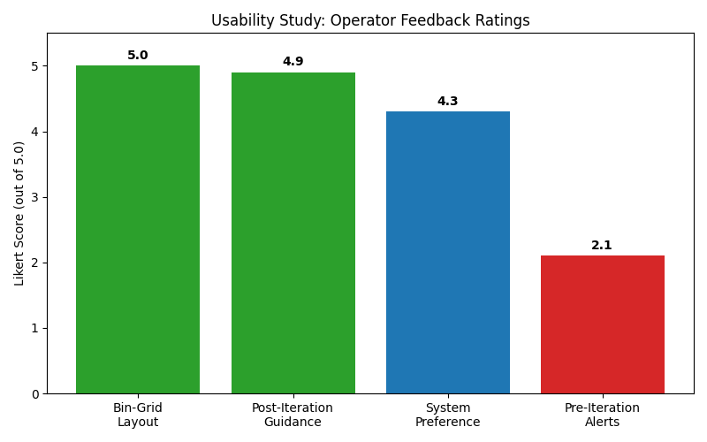
Figure A.1: Likert score distribution from operator usability study.

Appendix C: Load Cell Qualification Data
Raw calibration ladders, repeatability tables, hysteresis curves, warm-up drift logs, creep measurements, and off-centre deviation maps for all three configurations. Testing established a reliable noise floor threshold of 0.5 g on the 1 kg platform and 4.3 g on the 10 kg platform. Full raw data is available in the testing resource: AEGIS_LoadCell_Qualification.docx.

Appendix D: CV Training and Evaluation Data
YOLOv8-OBB training curves and validation metrics for Setup V3. As illustrated in Figure A.2 below, the vision system demonstrated perfect stability across all tested illuminance levels (0 to 506 lux). Furthermore, Phase 2 testing confirmed 100% bin detection accuracy across all varying part-contents and sizes (Figure A.3). Detection only degraded (80-85%) when introducing untrained mixed-colour bins. Full raw data is available in the testing resources: AEGIS_CV_Test_Pack.xlsx and lighting_cv_test_backup.xlsx.
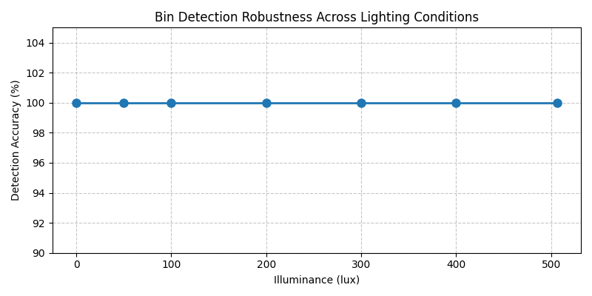
Figure A.2: Bin Detection Robustness Across Lighting Conditions, extracted from lighting_cv_test_backup.xlsx.
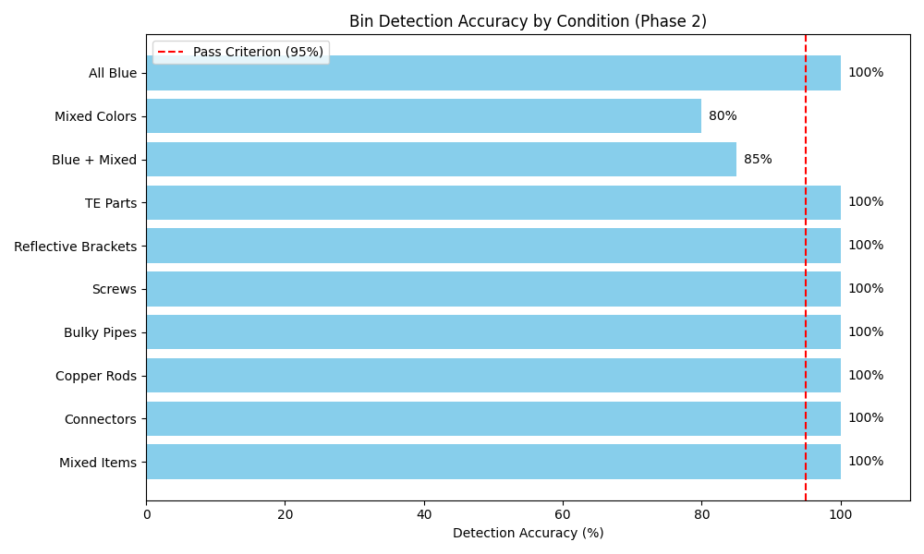
Figure A.3: Bin Detection Accuracy by Condition (Phase 2), extracted from AEGIS_CV_Test_Pack.xlsx.

Appendix E: HMI Screenshots
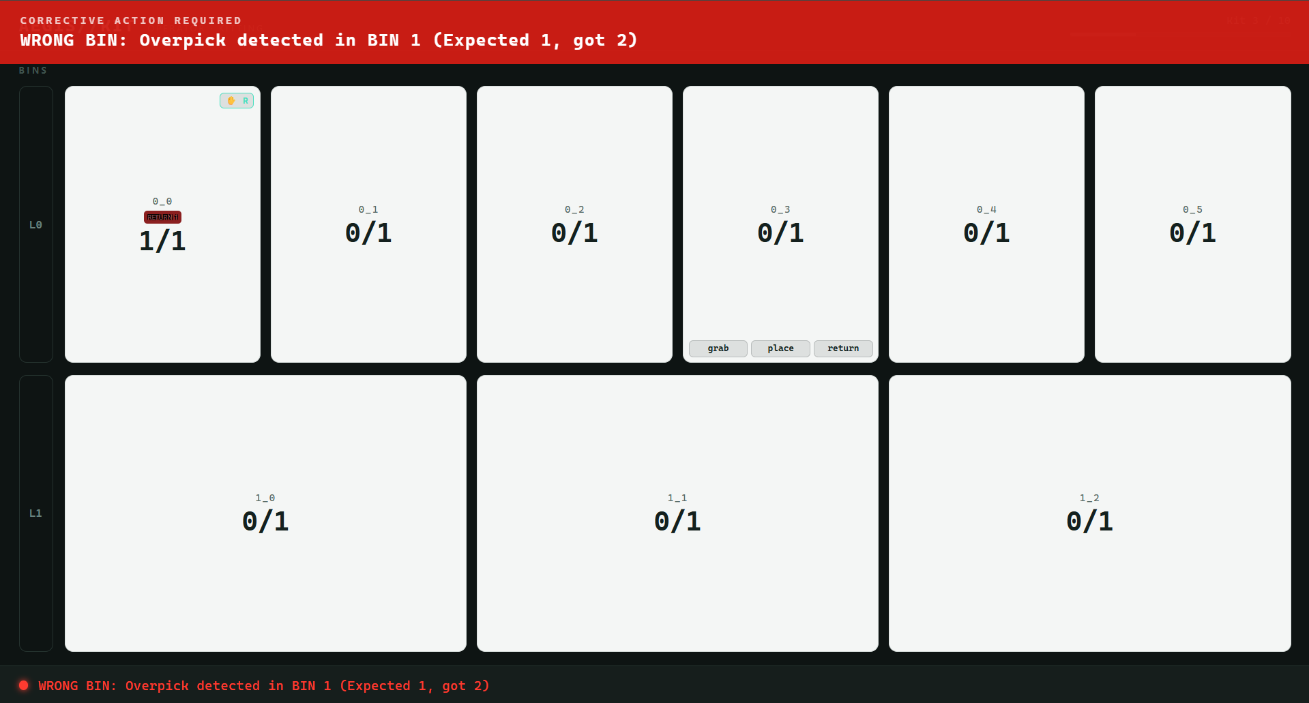
Figure A.4: Pre-iteration HMI showing the bin grid, small-font error banners, and 0-indexed labels.
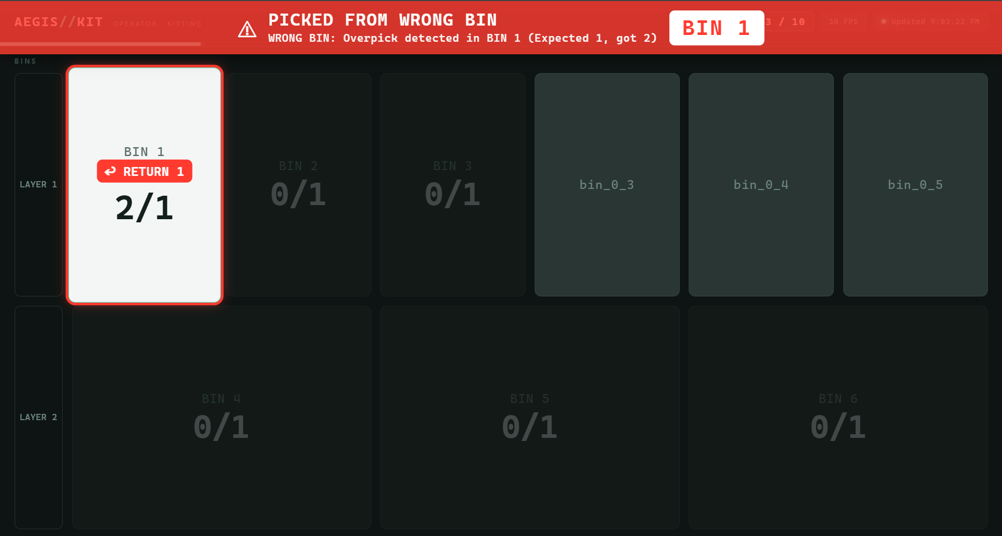
Figure A.5: Post-iteration HMI showing the redesigned fault banner, colour-coded hand halo, 1-indexed labels, and sets-remaining progress indicator.

Appendix F: Unit Test Summary
Full pytest output (134 of 134 tests passing) and pytest-cov coverage report.

Appendix G: TE Connectivity Stakeholder Interview Transcript
Us: Using my phone. Yeah, so maybe at the start we can reintroduce what the project is about. The first question we have is actually, what is the kitting problem and how much is it costing TE Connectivity? Maybe a short introduction on what the problem is from your perspective and the impact of these problems on the company as a whole.
Daryl: So for us, this issue has been brought up a few times by different plants, specifically kitting and packaging-related plants that face multiple issues of customer complaints due to mispackaged items. The errors range from missing items from the package to wrong items being packed. This leads to prominent complaints from customers that multiple different plants have actually faced, and even across multiple business units. That's where we feel that there needs to be a solution to ensure we solve this issue.
Us: Thank you. Moving on to another general question, now that you've seen the system at this more or less final stage of the prototyping process, what is your overall impression of the system in general?
Daryl: I'd say I'm actually quite impressed with the whole system. In terms of the entire hardware build as well as the software and all the thinking that went behind it—considering the different logical flows, process flows, UI, ergonomics, and all the various error cases—it's really well thought out.
Us: Thank you. Compared to the current measures implemented, like the manual checklist or the weighing at the end of the kitting process you mentioned, how does our system actually solve the gaps that those measures don't address? Maybe you could use one of the examples you mentioned.
Daryl: So currently, the kitting station employs a final weighing station once all the items are packed. But in those cases, once you measure and find a discrepancy, multiple items have typically already been packed inside. Identifying exactly which wrong piece or item was packed is very time-consuming. That's where we see a lot of inefficiency, and it costs us labor time. With this kind of poka-yoke design, the operators will know exactly when an error happens so they can catch it on the spot. This will drastically reduce that troubleshooting time. I think this is the most impactful part of the solution.
Us: Thank you. Leading on from that, is there any feature of our system that you didn't expect, or something we didn't heavily mention during presentations, that you thought was very useful?
Daryl: I would say it's the thought process behind the tiered bin system and ensuring it works well with both the camera system and the weight system. For example, you mentioned how even just showing 20% or 30% of the box still ensures all the bounding boxes work. I think these small features are actually quite important to the eventual full design. Also, the lighting tests, the error case handling, the warnings, and the UI indicators that provide guidance for operators—especially new operators. That's a feature I hadn't thought about before, but it will be very useful to a group of people within the plant.
Us: Okay, then maybe we'll move on to the limitations or any room for improvement. Is there any aspect of our project that you are skeptical about or have points of criticism on?
Daryl: I wouldn't say this is something I observed right now, but rather a potential issue. As highlighted earlier, very light items—under one gram, for example. In terms of how stable this current system is for those, I can't say for certain. My concern is that because it is so light, any debris or stray components falling into the bin might trigger false errors. This is one potential thing to take care of.
Us: We discussed this with supervisors, and they talked about bottlenecks in the line. A professor suggested that in the industry, people often branch these tedious processes out of the main line and conduct them separately before rejoining the line. If you want to branch it out for lighter objects, our system has the potential to handle it by using high-resolution, light load receptors (like 500g or 1kg cells instead of 5kg and 10kg). Then you do a separate kitting station for that, and the kits join back in.
Daryl: Yes, I think that makes sense. Also, regarding the high-mix, low-volume aspect, I don't know the entire range of bin configurations each plant has. Some bills of materials (BOMs) might just have a few items, while others have large quantities. If we set up these stations, we need to decide how many weight sensors of what configurations and sizes are needed. There will definitely still be some items that don't get a dedicated weighing scale, which is where the vision system comes in. As a proof of concept, I think this works very well already.
Us: We did a lot of limit testing. All the data for the load cells is primarily for the 1kg, 5kg, and 10kg platforms. Moving on to future-proofing: TE's product mix and skill mix are constantly changing. How well do you think our system can keep up with those changes? Is further rework required?
Daryl: For actual deployment, I know this is an MVP. Let's say for one station, a plant might require a different mix of scales. How can we make it easily configurable and modular such that if they buy one, they can just fix it right next to each other with a dedicated space? It needs to be easy to train on and easy to do changeovers in the future. Also, regarding the component database—currently, plants do not have a comprehensive database of all the unit weights of all their items. If there's one comprehensive database that can easily load all these unit weights and information for a setup, it will accelerate the deployment and utilization of this solution. The component weight registry sample you built helps this approach and is useful for the plant in the long run for future projects.
Us: You previously mentioned our system can be used beyond just kitting operations. Beyond kitting, do you see our system being useful anywhere else in TE's operations?
Daryl: Yes. We have multiple human-operated actions in the plant, and kitting is just one of them. Another big manual operation area is the assembly of parts. The logic utilized might be a little different, but there are overlaps. When they want to assemble a certain part, they take components from different boxes. For example, let's say I need to screw plates together and I need to screw five different areas. I can track that five screws were taken out, and with a weighing scale underneath, I can tell there's a weight difference. I see overlaps that can be adjusted to tackle assembly operations in TE as well. Where I see a gap in the industry is tracking the act of doing something—the process itself. Breaking it down step by step and alerting the operator before they actually make a mistake is very useful to explore.
Us: Moving on to deployment readiness. Our system can run on a live line, but there's an initialization process needed: images have to be taken of the bins, annotated, and the model trained. We also need the database of component metadata uploaded, and a way to assign which component is in which bin position. Does TE have any existing systems that could support these initialization steps?
Daryl: Short answer, no. I guess the closest thing would be a logic system that autonomously decides bin assignment—like prioritizing light items to the 1kg sensors. If you come up with a decent logic for assignment, the human can just do a final check and approval.
Us: Our system currently gives the operator a lot of freedom to pick from any bin. The professor suggested passing this onto a process engineer to optimize the picking sequence, pushing it onto the UI for the operator to follow.
Daryl: That's a good point to consider. It could help with speed, ergonomics (like left-hand vs. right-hand preferences), or organizing heavy items below lighter items. There's potential to actually reduce cycle time, not just avoid increasing it.
Us: Practically speaking, how close do you think this system is to something you could pilot in a real line? What are the missing elements before deployment?
Daryl: It depends on how easily users can configure the solution for themselves without needing to code. When they need to change the recipe, they must be able to change it with ease. In terms of the full application hardware and data testing, I would say it's about 80% done. The rest is just augmentations to ease human factors.
Us: Any closing remarks or advice for our team as we complete this project?
Daryl: I'm quite impressed with how you tested different edge cases and the questions you asked, even though you didn't have the opportunity to go on-site. You had the perspective to consider these things, which contributed to the success of the setup. If you hadn't considered them, a lot of edge cases might not have passed. You tested different lighting with a lux meter and checked stability, making the system very comprehensive. That's why I gave it a high score for deployment readiness. The best learning point moving forward would be to visit the plant to see real-life operations. That's how you truly understand the human aspect and come up with even better solutions.
Us: Thank you so much. Regarding deliverables, what would you like us to send you?
Daryl: For my team, a video of the whole setup is priority number one. Taking the operations from top-down, what the system sees, integrating the UI, camera, and the operator working on it—a split screen would be very useful. The code is also very important. I want to see how we can implement it in our plant and learn from your analysis.
Us: We have a second setup with the same PC. Is there anything you'd want us to try out?
Daryl: Actually, maybe a counter for each part, because it's a big workload. This is something the industry has always wanted. I think your system is very close to what we need. There are solutions in the market using pure vision systems, but they struggle with configuration and high-mix, low-volume setups. Your system has a distinct advantage there.
Us: Our system can fully replace the weighing scale. It uses three load cells instead of one for stability. Thank you so much for your feedback and advice!

